Data Sheet

Product | Bluetooth Low Energy Module
Solution | Nordic nRF52833 aQFN Package
Model NO. | DK9181B  (PCB Antenna)  DK9183B  (Chip Antenna)

Revision History
This table describes the changes to the specification.
Version | Date | Description
1.0.0 | 2024/05/23 | Initial Version
1.0.1 | 2024/05/30 | Add New Label
1.0.2 | 2024/05/31 | Add Marking On Metal Shield
1.0.3 | 2024/05/31 | Packaging Picture Correction

Index
- Overall Introduction……………………………………………………….………….……………………………………...5
  - Application………………………………………………………………............................................5
  - Product Specification………………………………………………………………………………………..…6

- Product Dimension…………………………………………………………….……….………………………………………8
2.1 PCB Dimensions＆Pin Indication……………………………………………………………………….8
2.2 Recommended Layout of Solder Pad………………….……………………………………………..9
2.3 RF Layout Suggestion (aka KEEP-Out Area)………………………………………………………10
2.4 Pin Assignment……………………………………………………………………………………………….11

- Main Chip Solution……………………………………………………………………………………………………………14

- Shipment Packaging Information………………..……………………………………………………………….…..14
  - Tape & Reel Packaging…………………………………….………………………………………………...15
4.2 Marking on Metal Shield…………………………………………………………………………………….18
- Specification…………………………………………………………………………………………………………………....19
  - Absolute Maximum Ratings……………………………………………………………………………....19
  - Operating Conditions…………………………………………………….....................................19
  - Electrical Specifications……………………………………………………………………………………..20

- Block Diagram……………………………………………………..…………………………………………………………..27

- Antenna…………………………………………………………………………………………………………………………...28
  - DK9181B……………………………………………………………………………………………………………28
  - DK9183B……………………………………………………………………………………………………………28

- Reference Circuit…………………………………………………………….…………………………………………….….29
  - Reg0 LDO Mode…………………………………………………………………………………………….…..30
  - Reg0 LDO Mode Disabled……………………………………………………………………………….….32
  - USB Powered…………………………………………………………………………………………………....34
  - USB Disabled……………………………………………………………………………………………………..36

- Notes and Cautions………………………………………………………..……………………………………………...38

- Basic Facts for nRF52 Family………………………………………..………………………………………..………39
.
- Useful Links……………………………………………………………………….………………………………………...40
Full List of Dexatek’s BLE Modules…………………………………………….……………………………………………..40

Overall Introduction

Dexatek’s DK9181B & DK9183B is a BT 5.1 stack (Bluetooth low energy or BLE) module designed based on Nordic nRF52833 SoC solution, which incorporates: GPIO, SPI, UART, I2C, I2S, PMD, PWM, ADC, NFC and USB interfaces for connecting peripherals and sensors.

Ideal solution for designs requiring Bluetooth 5 functionality or 802.15.4-based Thread networking
and Zigbee. Enhanced integration with built-in USB and 5.5 V compatible DC/DC power supplies reduces design complexity and BOM cost while expanding possible applications.

Provides ultra-low power consumption and excellent wireless range with +8 dBm transmission
Power and long range (encoded physical layer) Bluetooth 5 capabilities. New circuits are added
TX power and reduces sleep current for perfect power management.

  - Application
- Lighting products
- Home application
- Internet of things (IoT)
- Medical devices
- Factory automation
- IoT Sensors
- HVAC Controllers
- Industrial IoTsensors and Controllers
- Remote controls
- Smart Eenergy management
- Advanced Wearables
- Education entertainment devices
- Agriculture Application

1.2 Product Specification
- Bluetooth ® 5.3 IEEE 802.15.4-2006, 2.4 GHz transceiver,
- LE 2M PHY, LE 1M PHY, LE Coded PHY (Long Range)
• 2 Mbps, 1 Mbps, 500 kbps, and 125 kbps
• IEEE 802.15.4-2006 – 250 kbps
• Proprietary 2.4 GHz – 2 Mbps, 1 Mbps
- nRF52833, ARM ® Cortex ® M4 32-bit processor with FPU, 64 MHz
- 512kB Flash and 128 kB RAM
- 1 MB Flash and 256 kB RAM
- Radio
• GFSK at 1 Mbps and 2 Mbps, QPSK at 250 Kbps
• -96 dBm sensitivity in 1 Mbps Bluetooth ® low energy mode
• -103 dBm sensitivity in 125 kbps Bluetooth ® low energy mode (long range)
• -20 to +8 dBm TX power, configurable in 4 dB steps
• On-air compatible with nRF52, nRF51, nRF24L, and nRF24AP Serie
- Power Management
• 1.7 V to 5.5 V supply voltage range
- Security features
• ARM ® TrustZone ® Cryptocell 310 security subsystem
• 128-bit AES/ECB/CCM/AAR co-processor
• Secure erase
- Peripheral interface / Hardware
• USB 2.0 full speed (12 Mbps) controller
• QSPI 32 MHz interface
• High-speed 32 MHz SPI
• Type 2 NFC-A tag with wake-on field
• Touch-to-pair support
• Programmable peripheral interconnect (PPI)
• 42 general purpose I/O pins (GPIO)
• EasyDMA automated data transfer between memory and peripherals
• Nordic SoftDevice ready with support for concurrent multiprotocol
• 12-bit, 200 ksps ADC – 8 configurable channels with programmable gain

• 64 level comparator
• 15 level low-power comparator with wake-up from System OFF mode
• Temperature sensor
• 4x4 channel PWM unit with EasyDMA
• Audio peripherals – I2 S, digital microphone interface (PDM)
• 5x 32-bit timer with counter mode
• Up to 4x SPI master/3x SPI slave with EasyDMA
• Up to 2x I2 C compatible two-wire master/slave
• 2x UART (CTS/RTS) with EasyDMA
• Quadrature decoder (QDEC)
• 3x real-time counter (RTC)
- Operation Temperature: -40 °C to 85 °C

Product Dimension

2.1. PCB Dimensions & Pin Indication 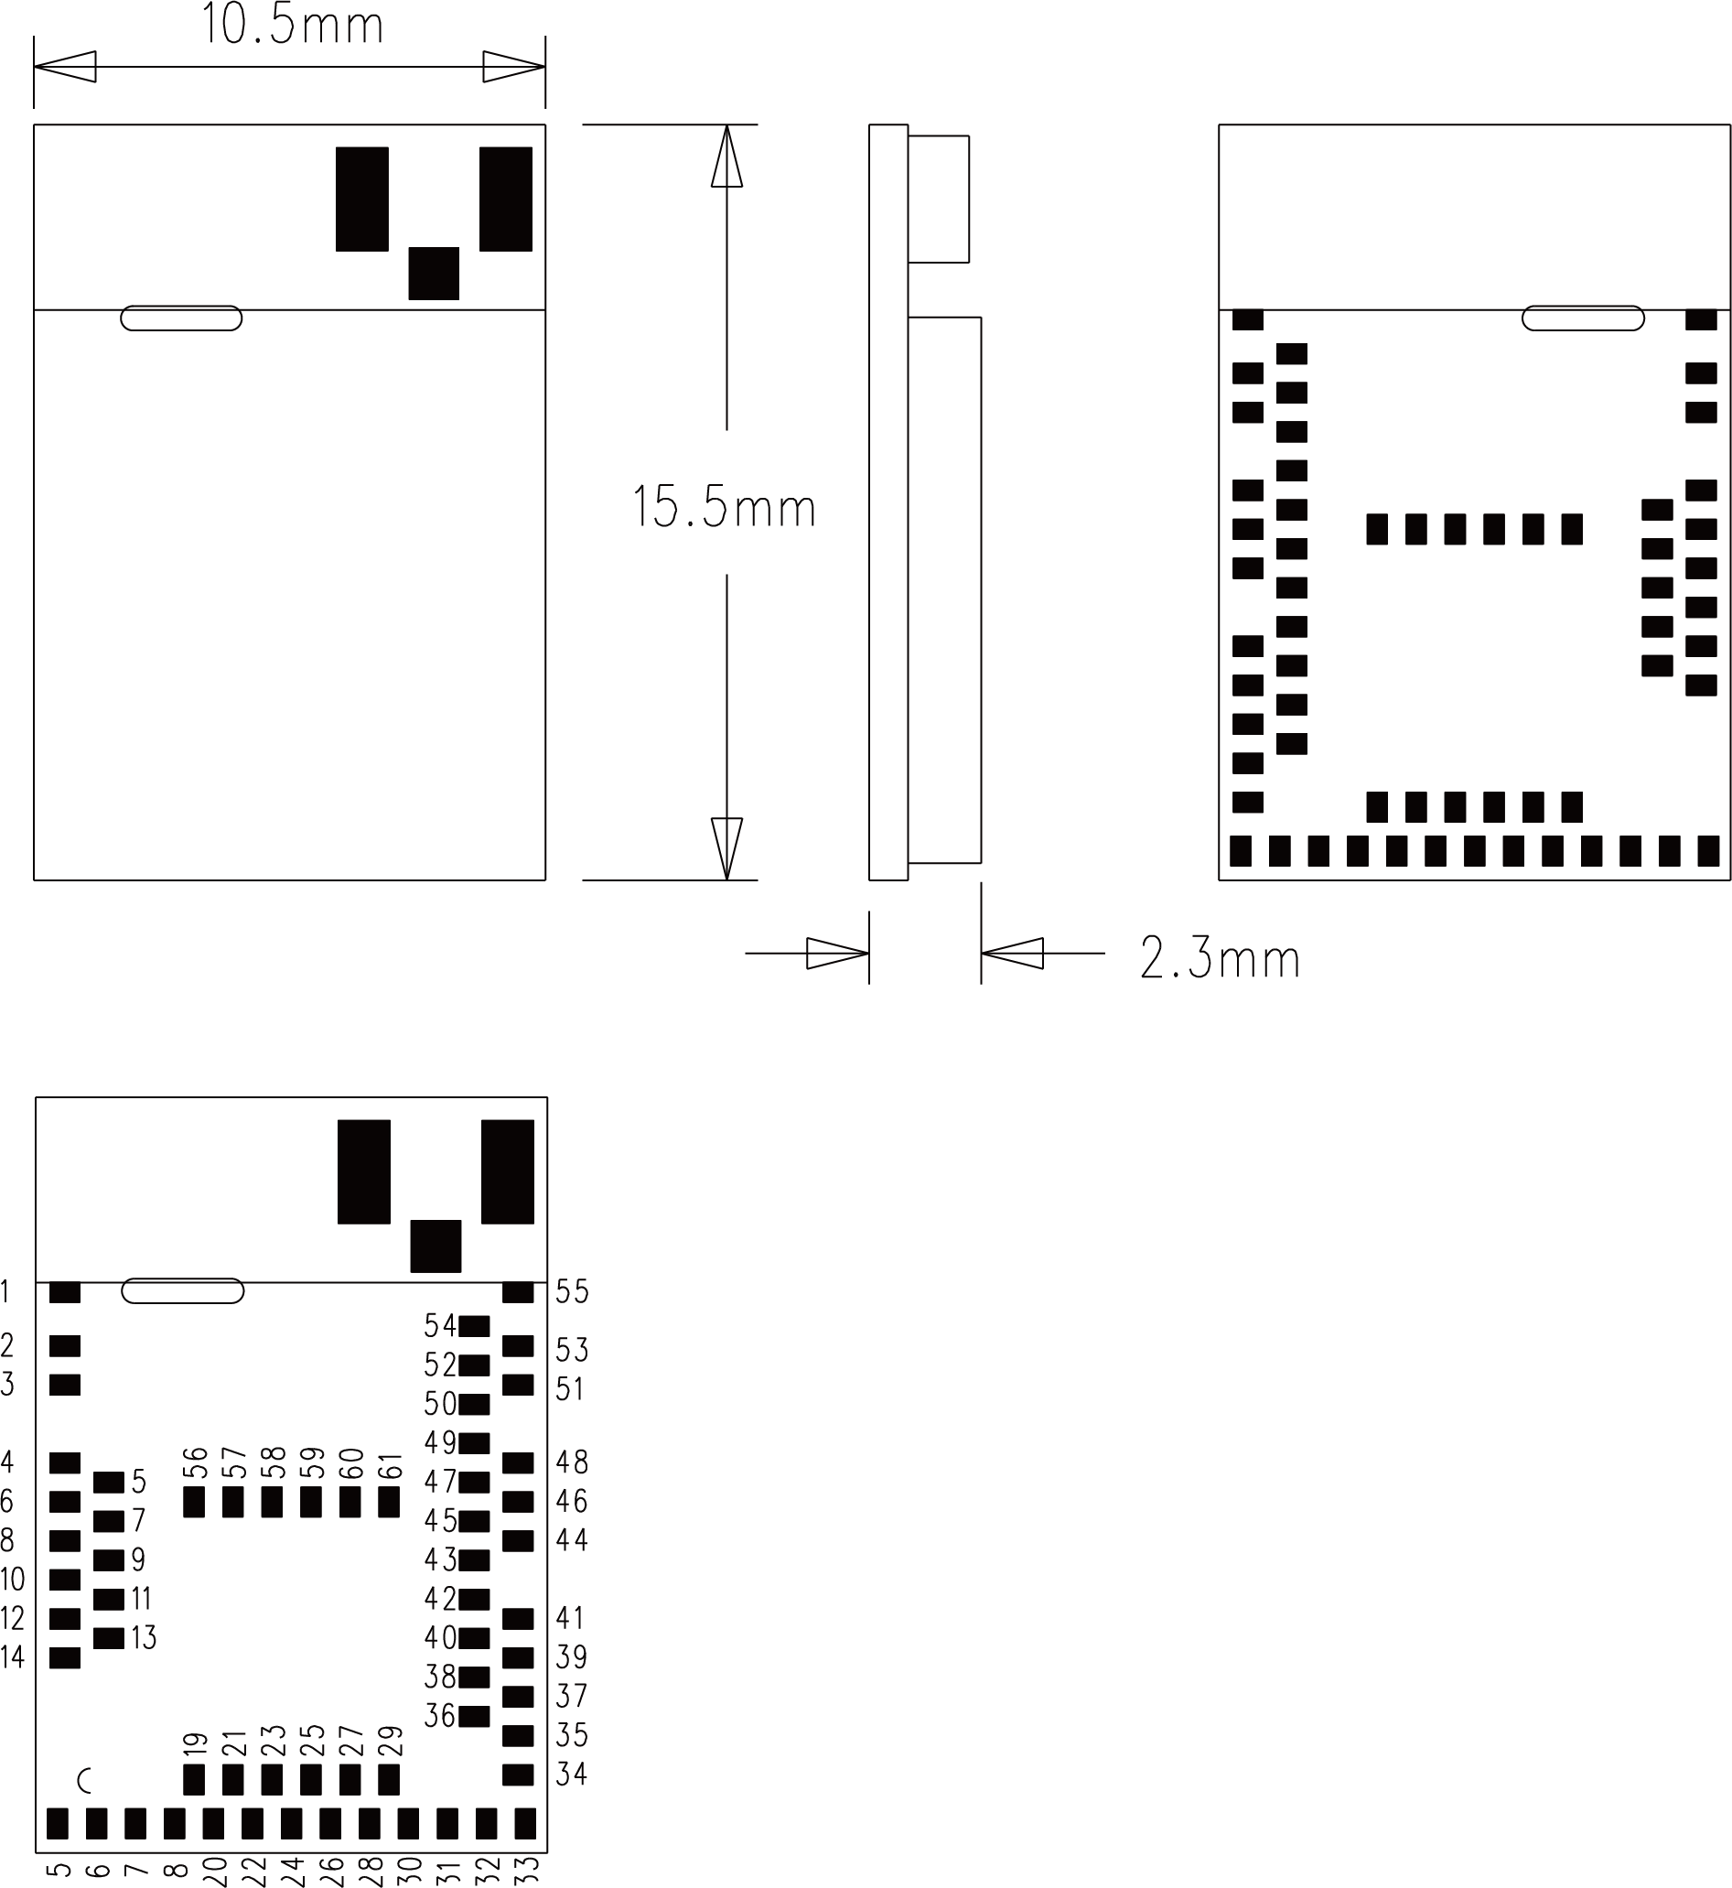

2.2. Recommended Layout of Solder Pad
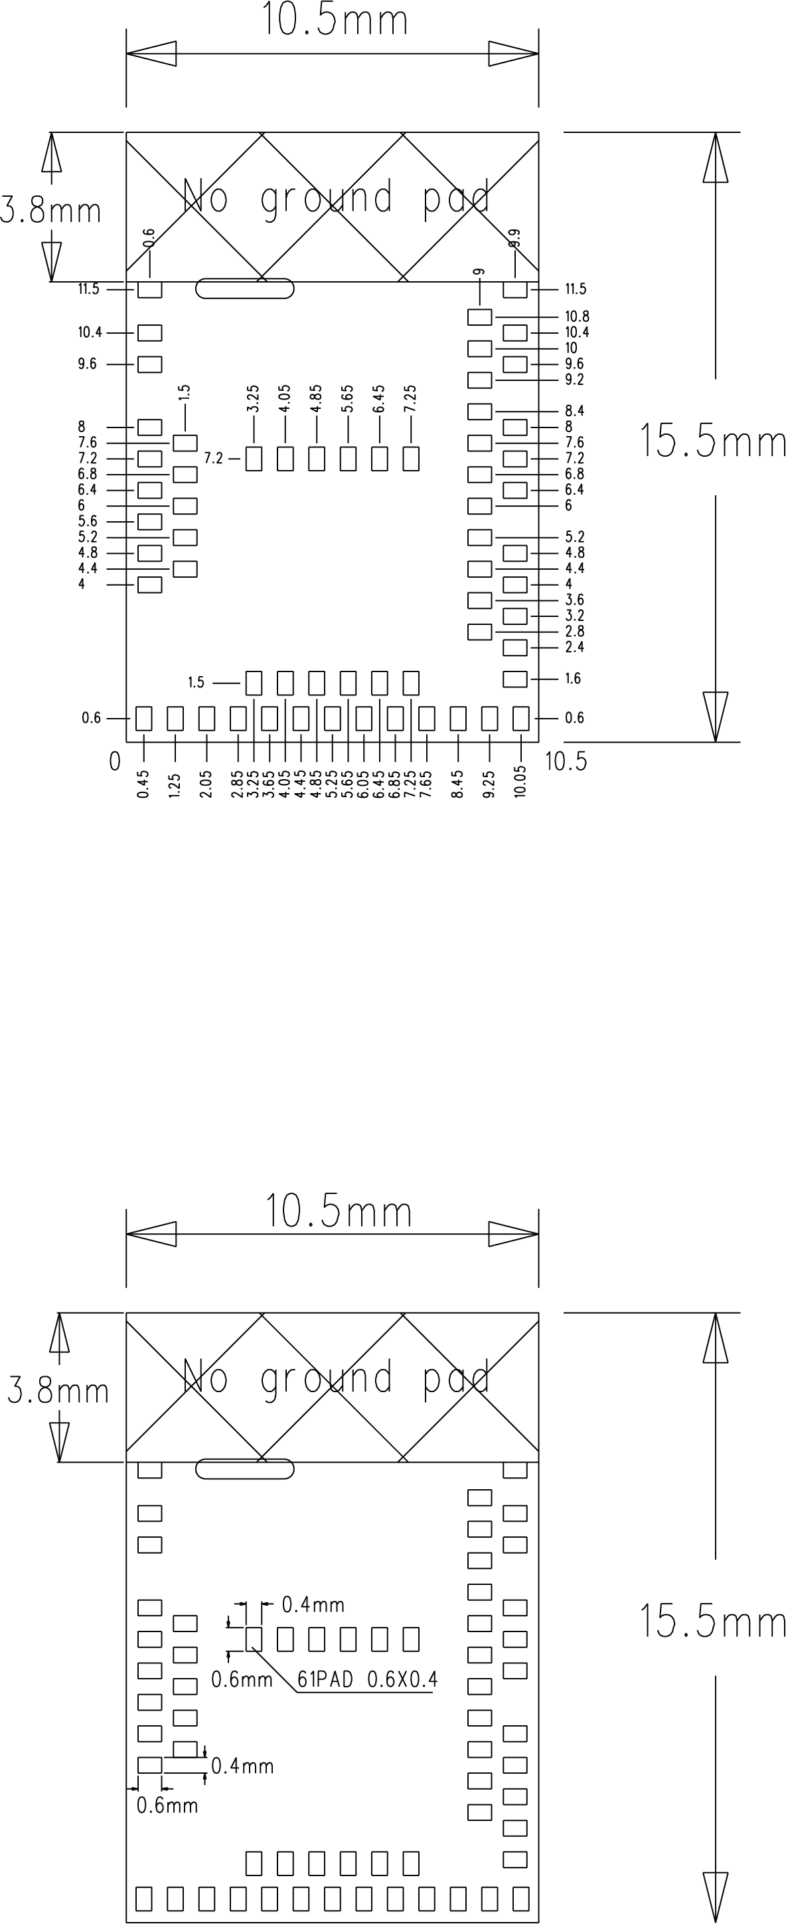

2.3. RF Layout Suggestion (aka Keep-Out Area)
Please follow below instruction to avoid from having Ground Pad in the area of our RF test pad. Otherwise, it may cause shortage to the module
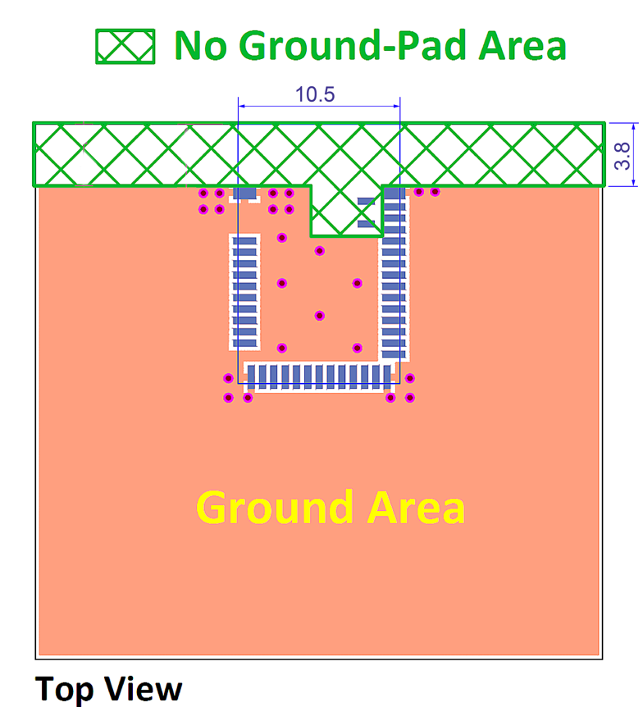

2.4. Pin Assignment
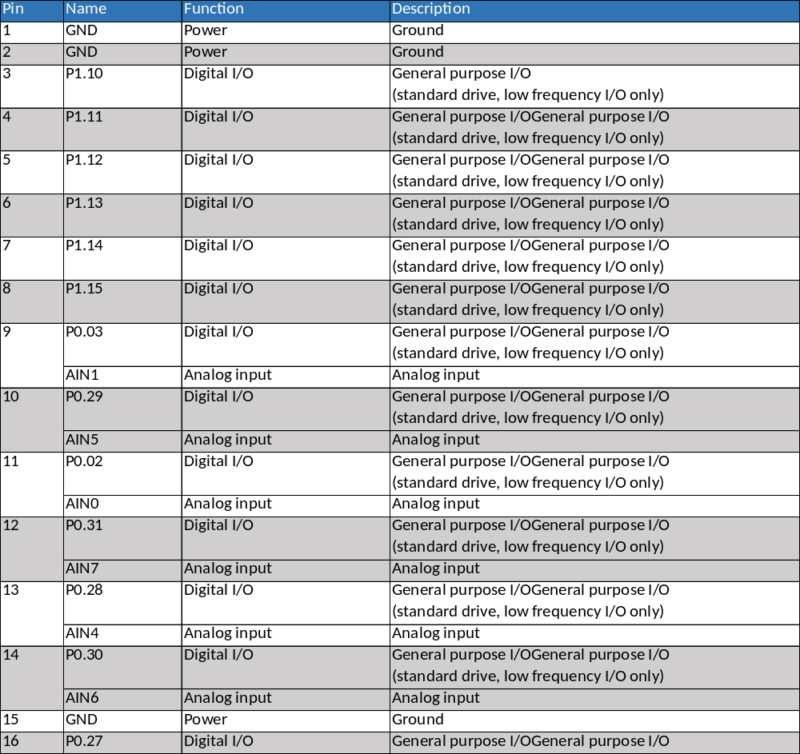
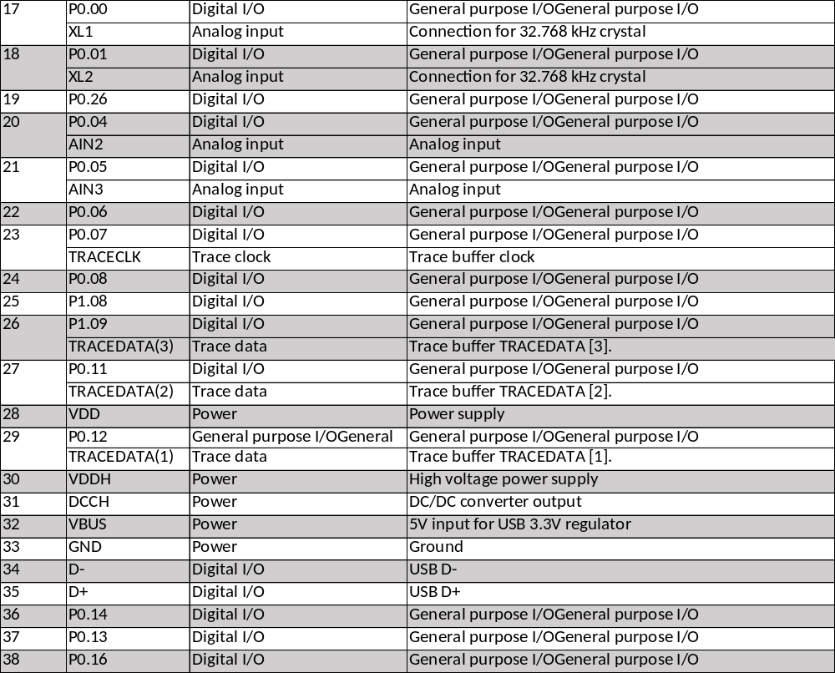
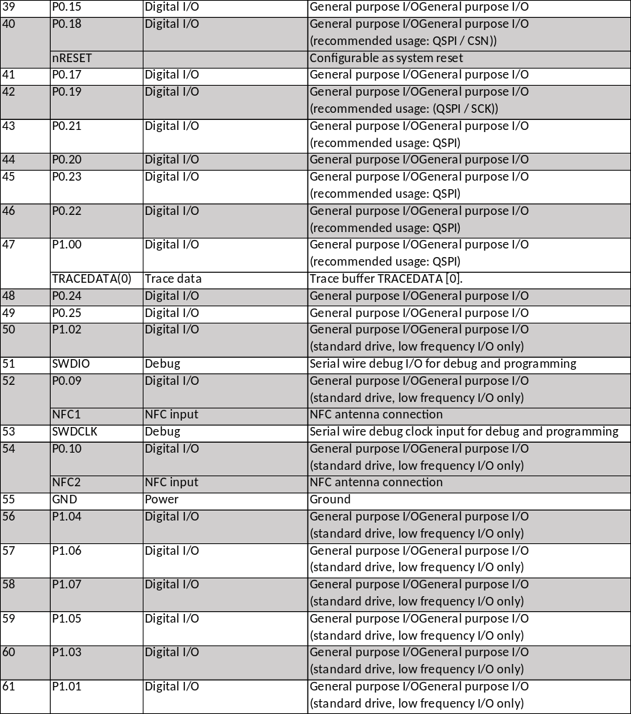

3. Main Chip Solution

RF IC | Crystal Frequency
Nordic NRF52833 | 32MHZ

32MHz crystal and RF (VDD) DC/DC inductor (Reg1) are already inside the module.

4. Shipment Packaging Information

Model | Antenna | Photo
DK9181B | PCB | 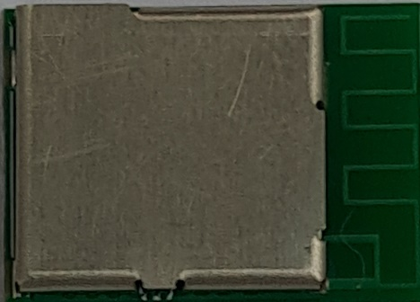
DK9183B | Chip/Ceramic | 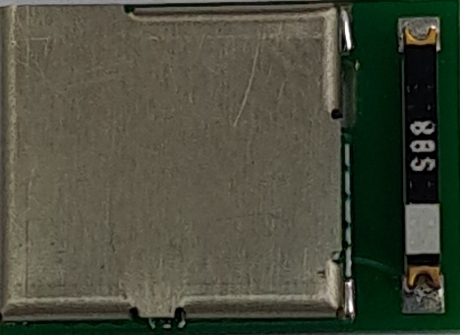

※Unit Weight of Module: 0.68g (±0.02g)
※Packaging Type: Anti-static Tape & Reel

 | Tape & Reel
MPQ  (Min. Package Qty) | 600 pcs per reel
Carton Contents  (per Carton) | 600 pcs
Carton Dimension  L*W*H cm | 37*36*6
Gross Weight | About 1.9kgs

4.1 Tape & Reel Packaging
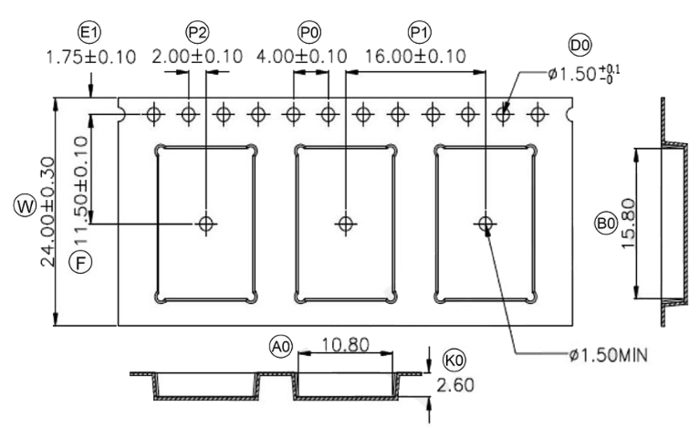

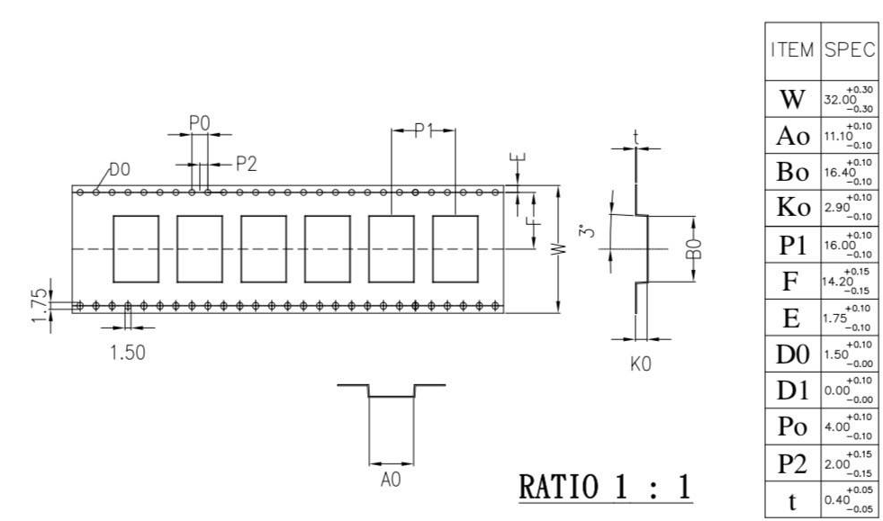

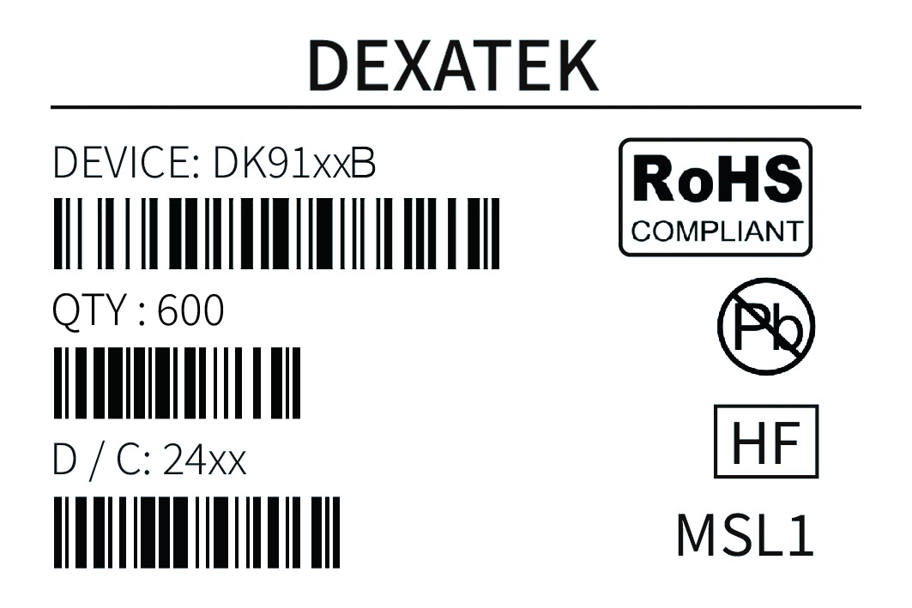

Part Number | DK91xxB
Quantity | 600 pcs
Date Code | 24xx

4.2. Marking on Metal Shield
4.2.1. Label

DK9181B
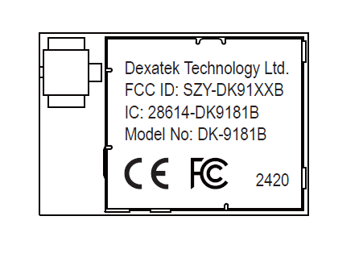
DK9183B
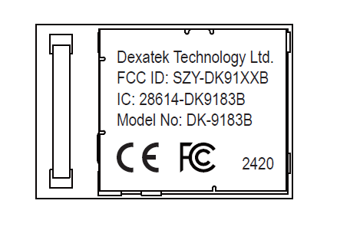

5. Specification
Any technical spec shall refer to Nordic’s official documents as final reference.

5.1. Absolute Maximum Ratings
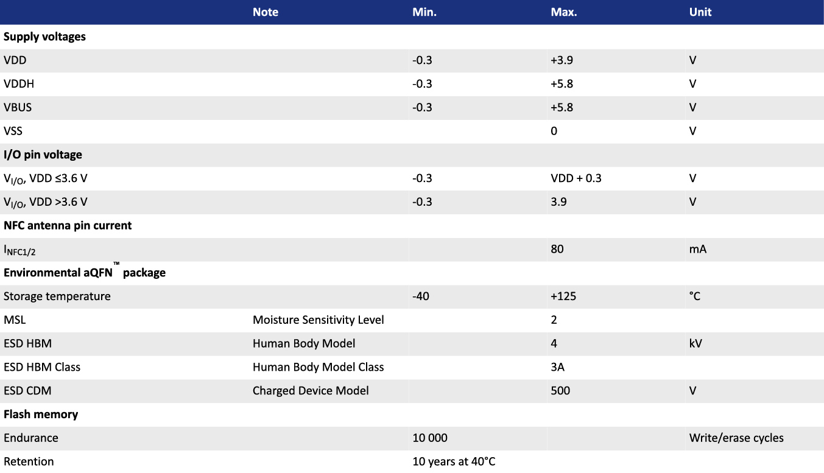

5.2. Operating Conditions
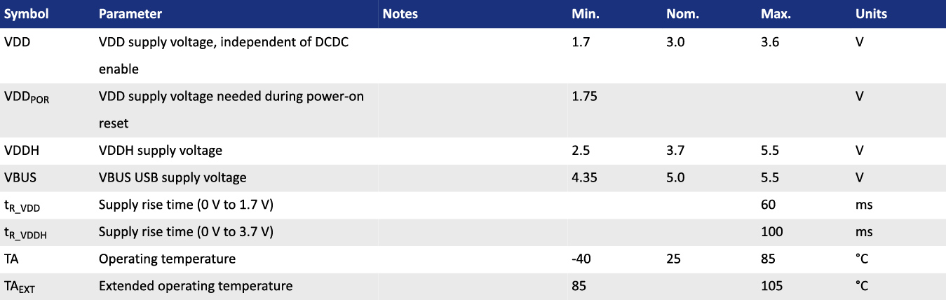

5.3. Electrical Specifications

5.3.1. General Radio Characteristics
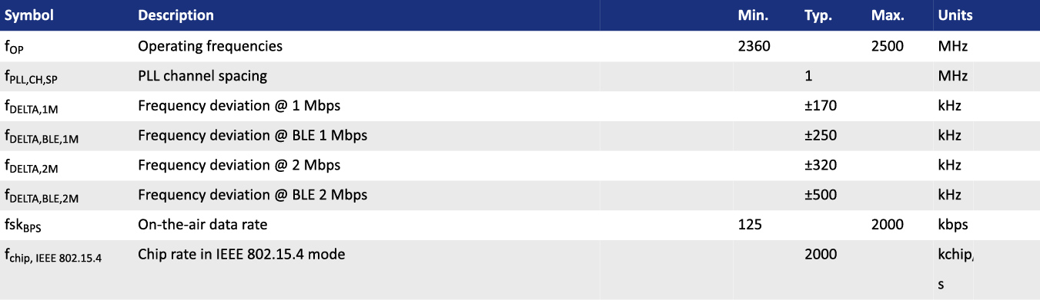

5.3.2. Radio Current Consumption (Transmitter)
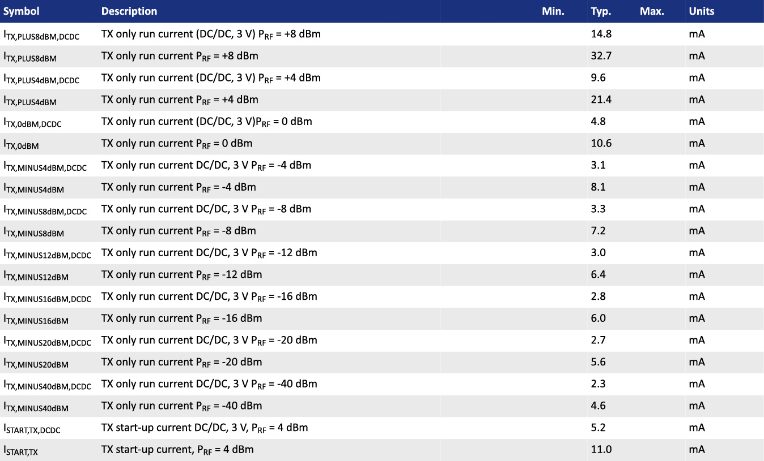

5.3.3. Radio Current Consumption (Receiver)
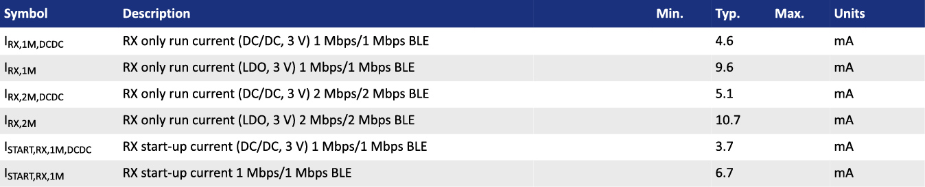

5.3.4. Transmitter Specification
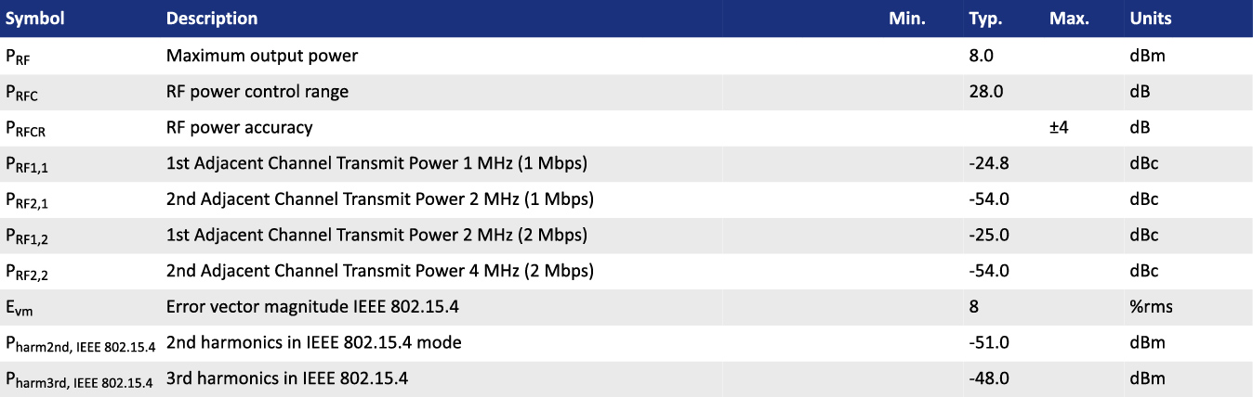

5.3.5. RSSI Specification
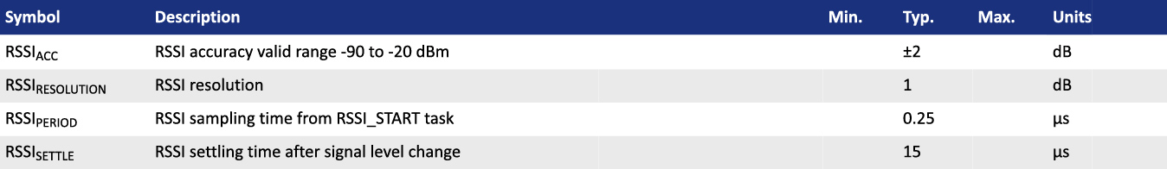

5.3.6. Receiver Operation
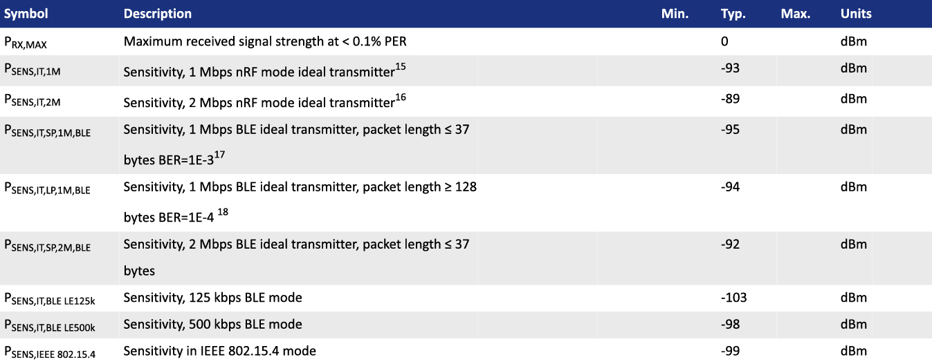

- Typical sensitivity applies when ADDR0 is used for receiver address correlation. When ADDR[1...7] are used for receiver address correlation, the typical sensitivity for this mode is degraded by 3 dB.
- Same as remark 1.
- As defined in the Bluetooth Core Specification v4.0 Volume 6: Core System Package (Low Energy Controller Volume).
- Equivalent BER limit < 10E-04.

5.3.7. RX Selectivity
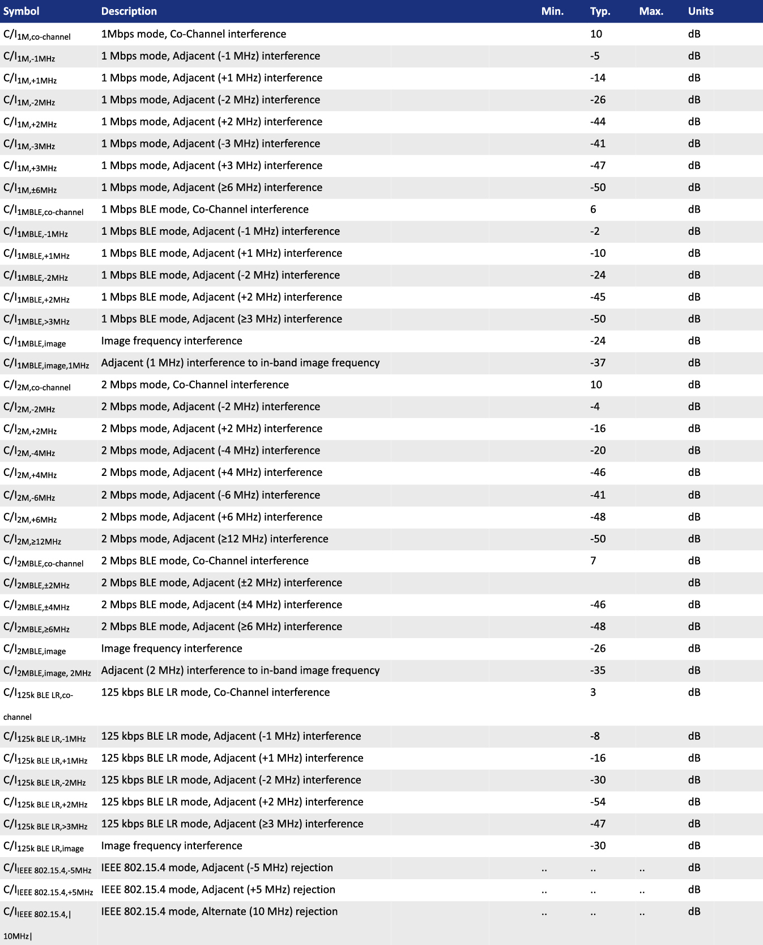

1. Desired signal level at PIN = -67 dBm. One interferer is used, having equal modulation as the desired signal. The input power of the interferer where the sensitivity equals BER = 0.1% is presented.

5.3.8. RX Intermodulation
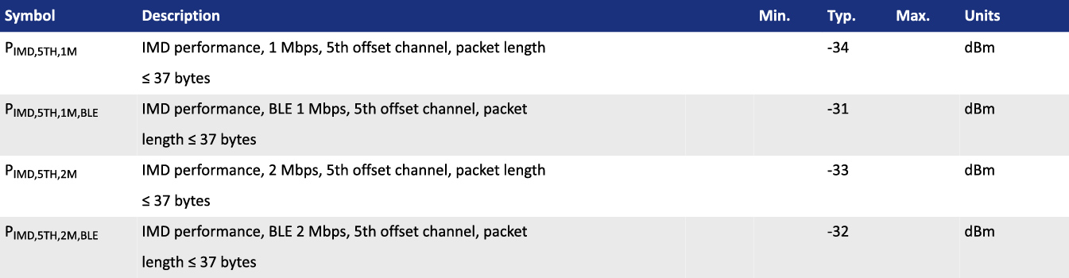

5.3.9. Radio Timing
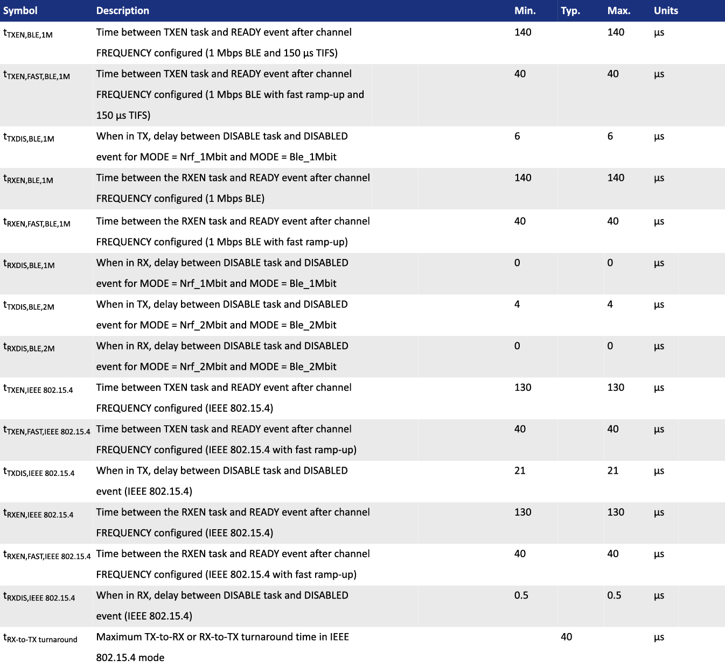

5.3.10. CPU
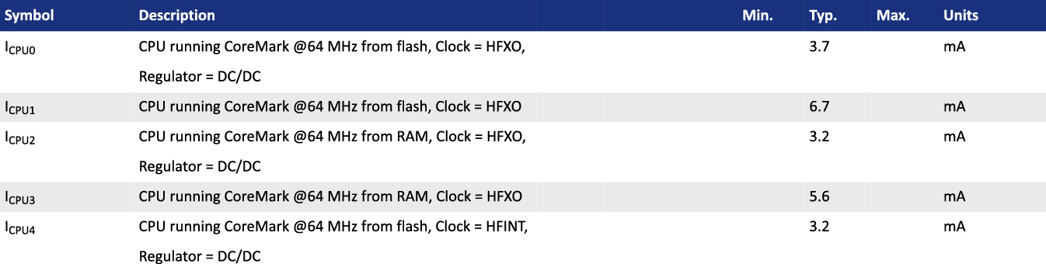

5.3.11. Power Management
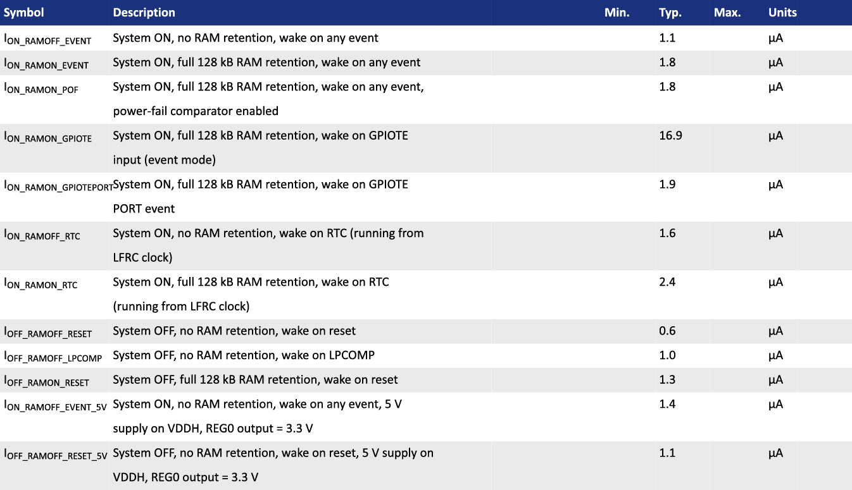

6. Block Diagram
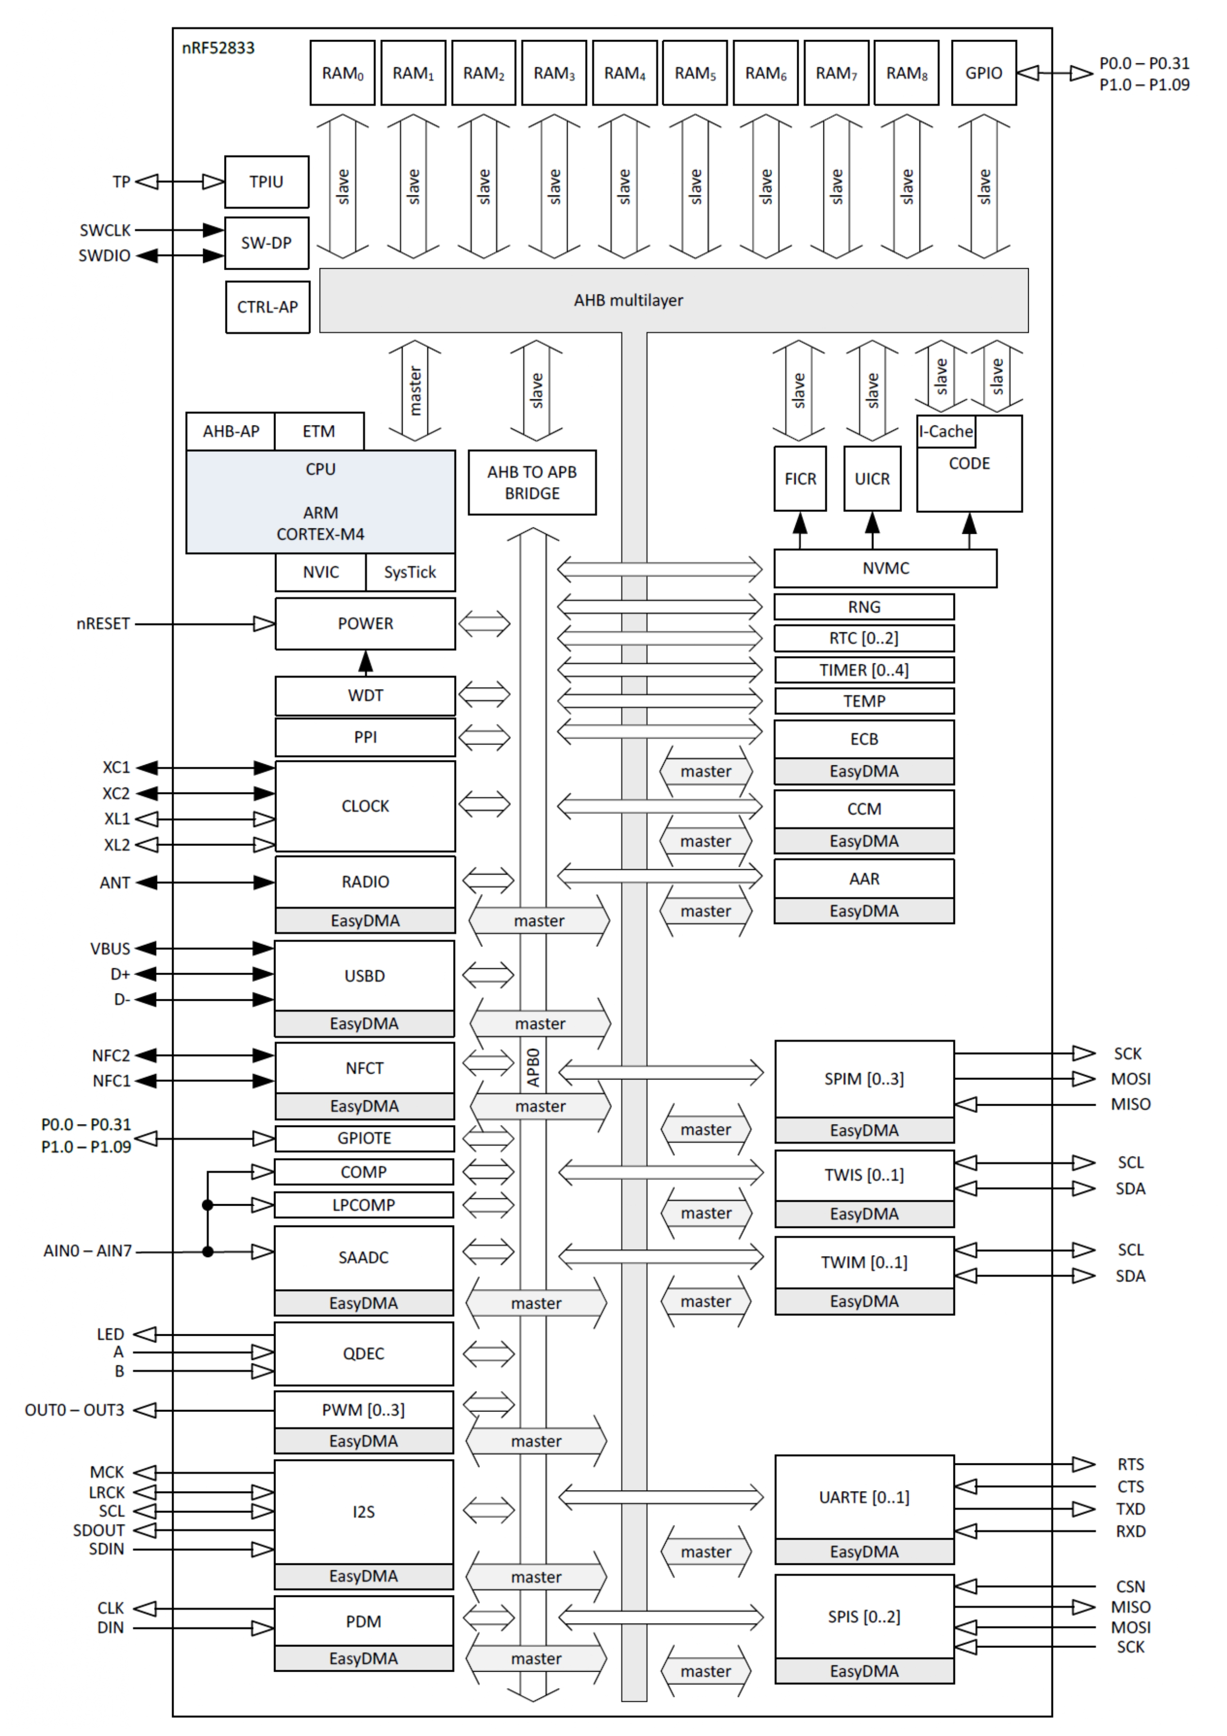

7. Antenna
Below chart shows a few options of external antenna which has been tested and approved to use with DK9181B & DK9183B
DK9181B
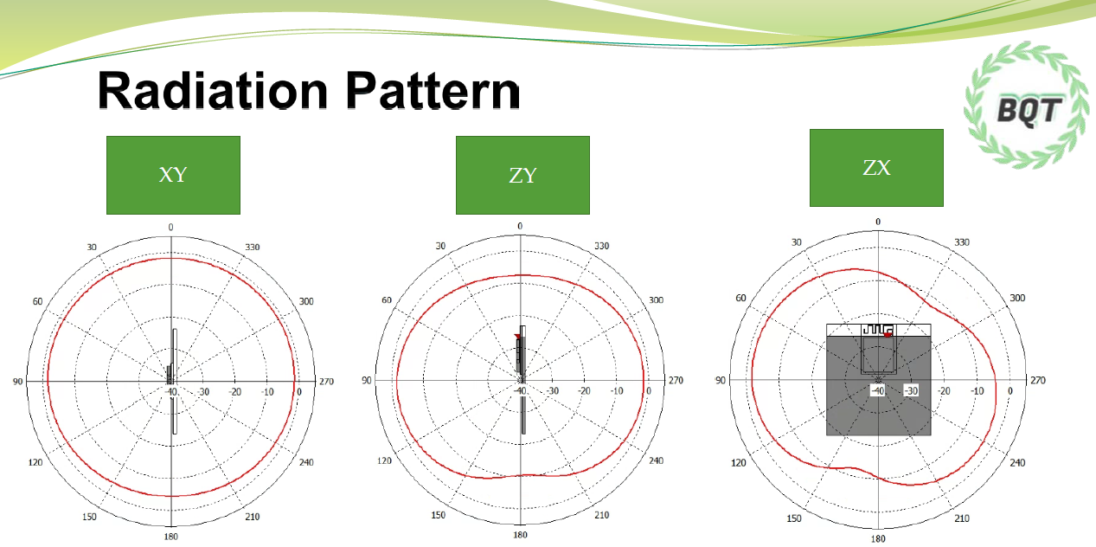
DK9183B
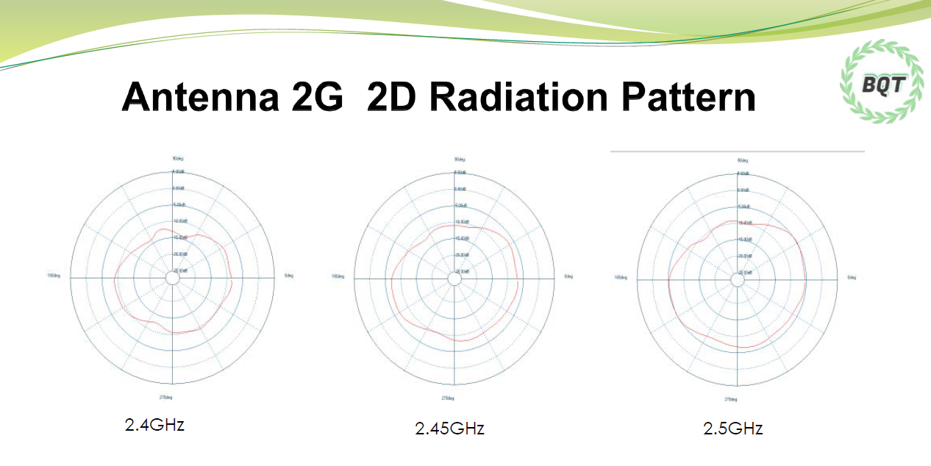

8. Reference Circuit
This is a notification for circuit combinations and please refer below caution for specification, and carefully in detail description as applies to adapt on peripherals circuits.

⚫ The Modules pre-programmed Dexatek test code inside. Modules default is define LDO mode in firmware and it have to plus external 32.768khz oscillator for MCU boot and work for.
Once it removed external crystal of 32.768khz, the system would be boot up from internal crystal.
⚫ When not using NFC, please remove NFC Radio Frequency Coil and C235/C236/C237/C238
⚫ Please remove Y1/C7/C9 when using the internal 32.768khz RC oscillator.
⚫ 32MHz crystal oscillator and RF (VDD) DC/DC inductor (Reg1) are built in the module.

8.1. Reg0 LDO Mode
Recommend using when the highest input voltage is equal or greater than 3.6V. Supply power from VDDH.

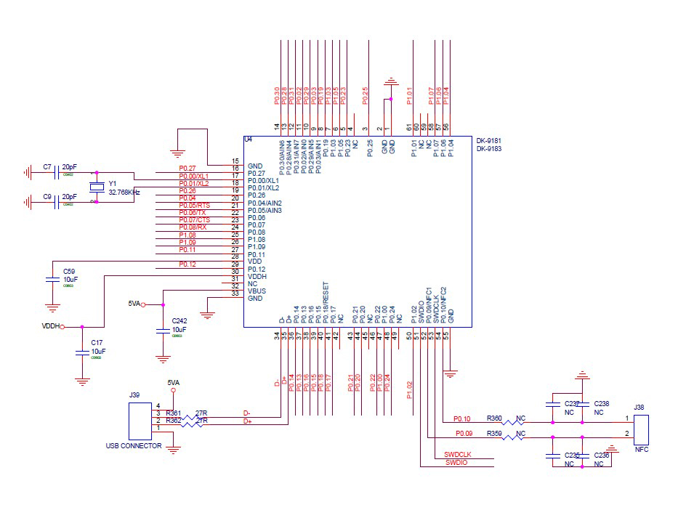

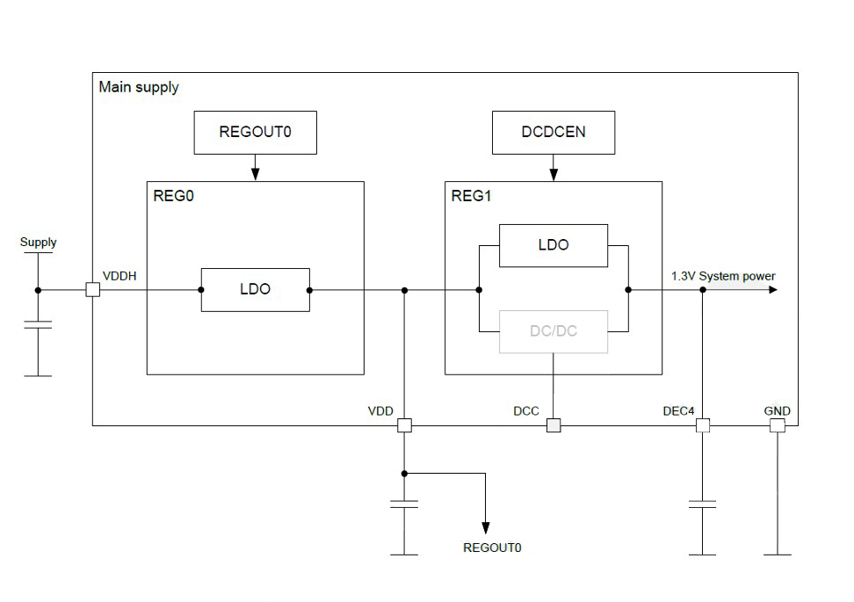
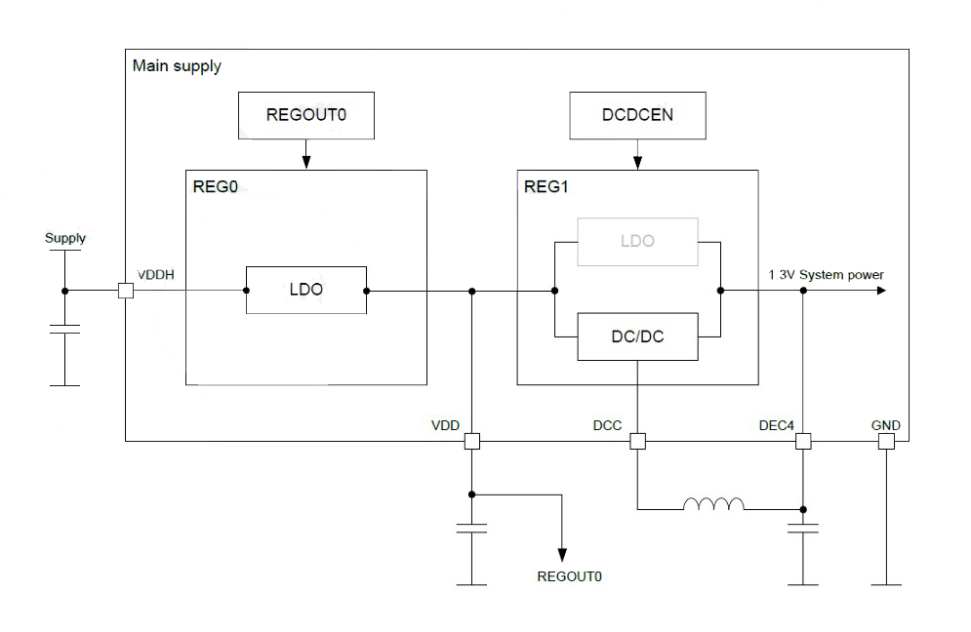

8.2. Reg0 LDO Mode Disabled
Recommend using when the highest input voltage is less than 3.6V.

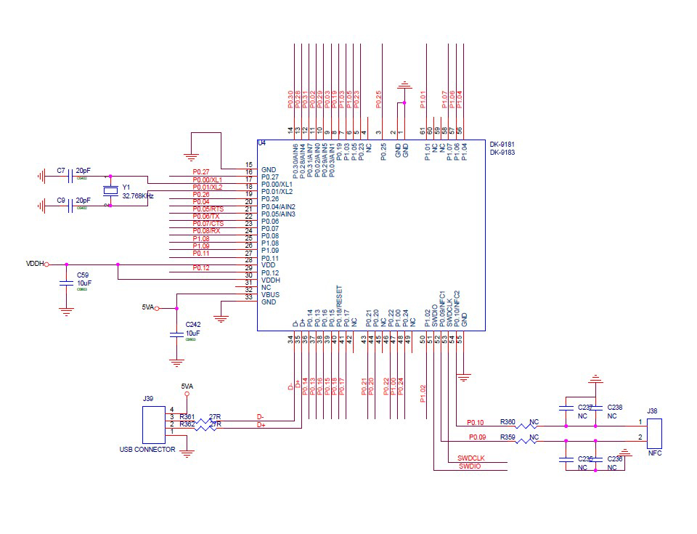

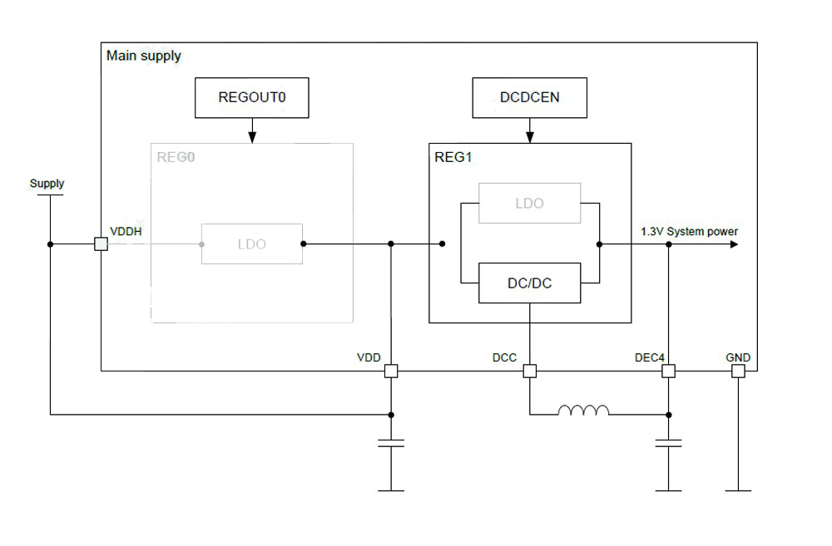

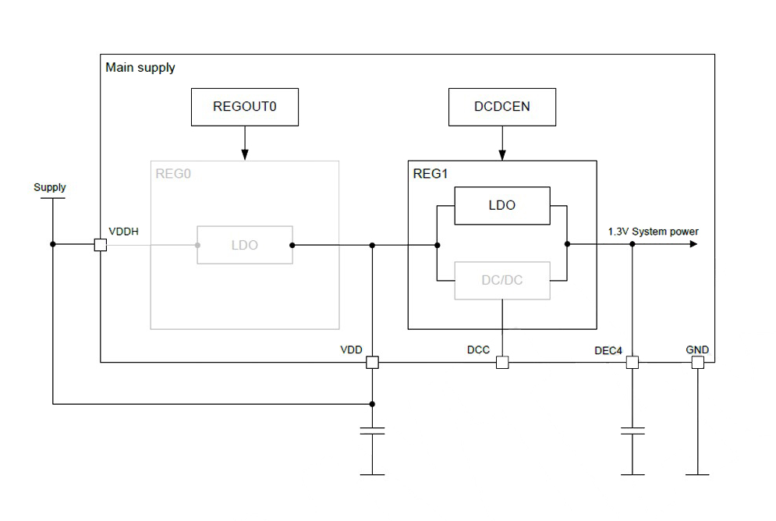

8.3. USB Powered
Recommend using when power the device via USB

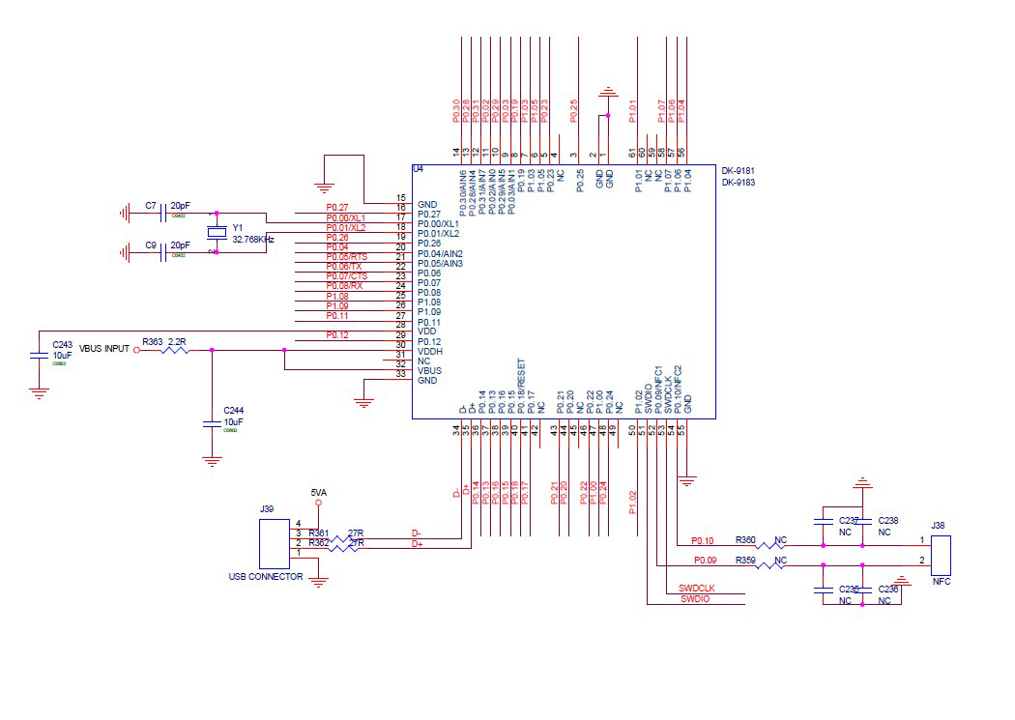

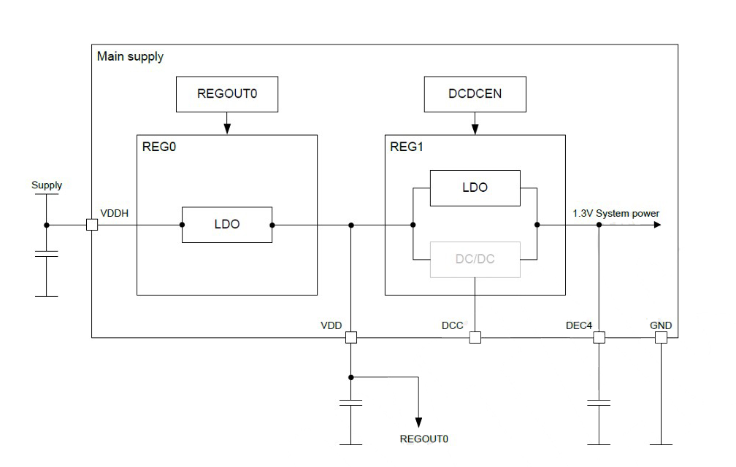

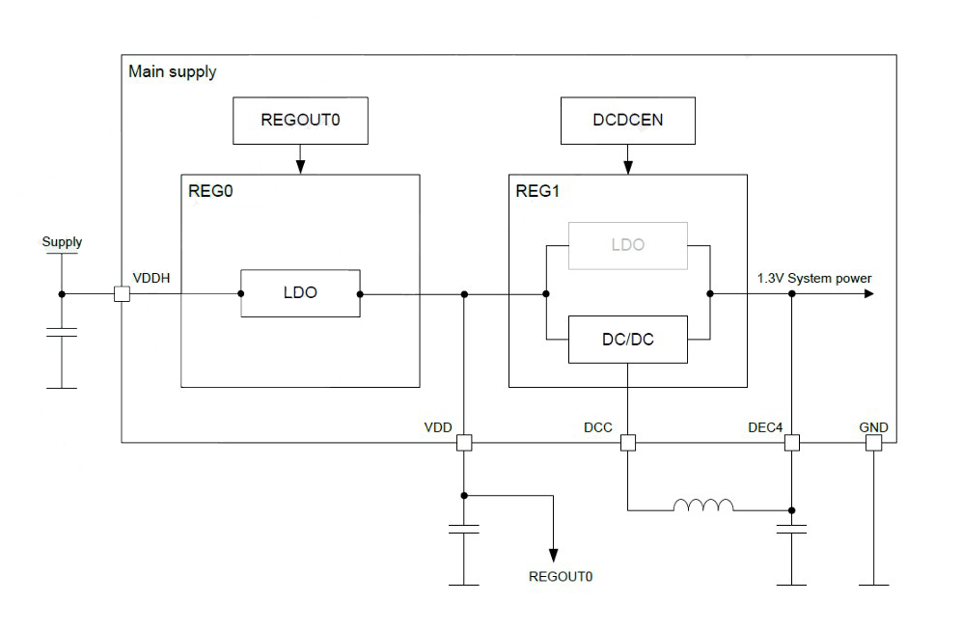

8.4. USB Disabled
This circuit only focuses on USB disabled. Please leave D+ & D- as NC when USB is disabled.

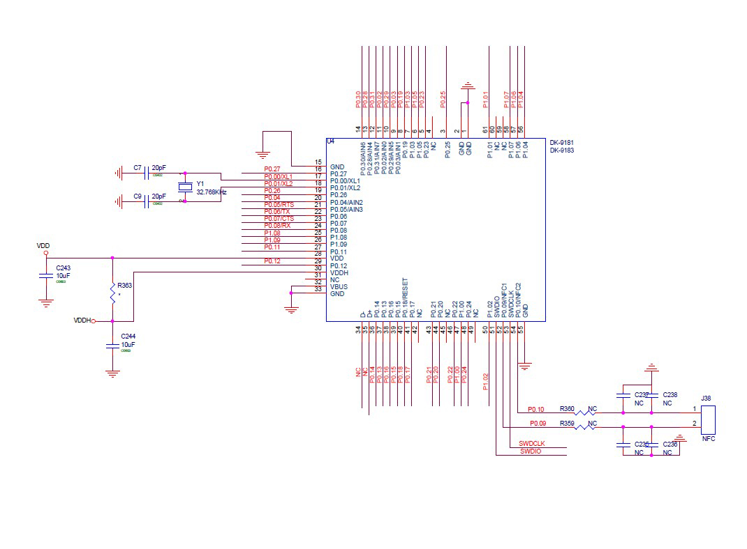

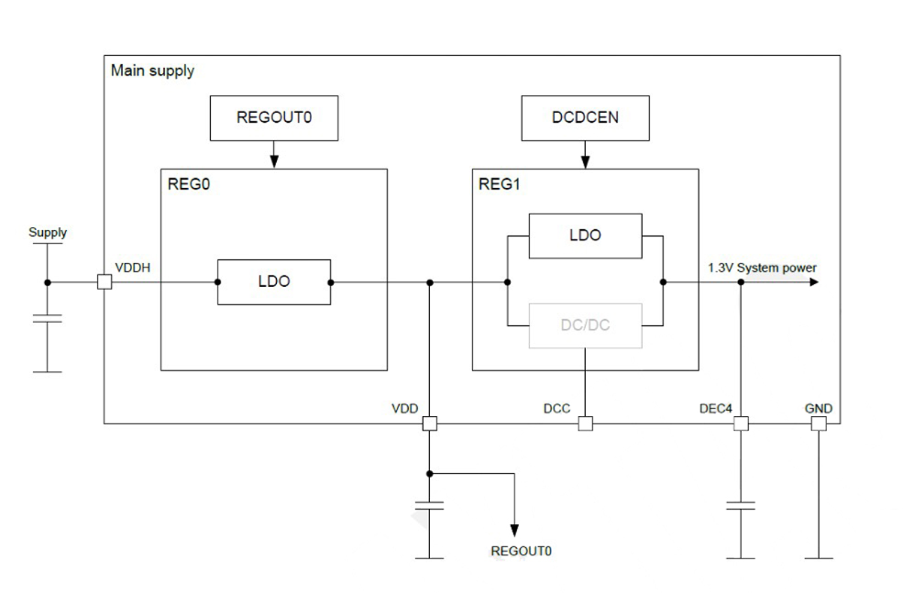
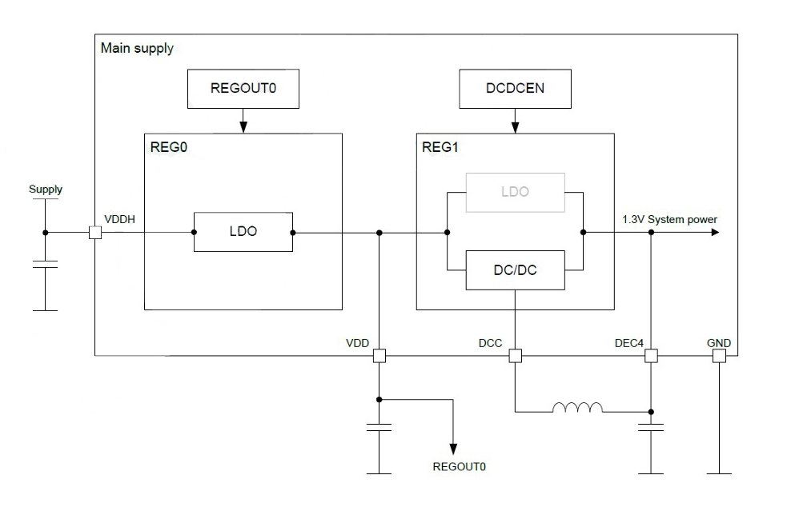

9. Notes and Cautions
1. Follow the conditions written in this specification, especially the control signals of this module.
2. The supply voltage should abide by the maximum ratings and must to supply within range of specification.
4. This module should not be mechanically stressed when installed.
5. Keep this module away from heat. Heat is the major cause of decreasing the life time of these modules.
6. Avoid assembly and use of the target equipment in conditions where the module temperature may exceed the maximum tolerance.
7. Keep this module away from other high frequency circuits.
8. Refer to the recommended pattern when designing a board.
9. Do not expose modules under direct sunlight for long duration. Modules should be kept away from humid and salty air conditions, and any corrosive gasses or substances. Store it within -40℃ to +125℃ before and after installation.

10. Basic Facts for nRF52 Family

Below chart shows basic spec for Nordic nRF52 family, which is helpful to understand the differences between each SoC. Any discrepancy shall referto Nordic’s technical document as final reference.
Solution | Nordic  52840 | Nordic  52833 | Nordic  52832 | Nordic  52810
Antenna | Ipex |  | Ipex
Antenna Vendor | Χ |  | Χ
RAM (KB) | 256KB | 128KB | 64KB | 24KB
Internal Flash | 1MB | 512KB | 512KB | 192KB
External flash | Χ | Χ | Χ | Χ
PIN OUT | 48 | 42 | 32 | 32
Shielding Case | O | O | O | O
Package | 6x6mm QFN48 | 7x7mm aQFN™73 | 6x6mm QFN48 | 6x6mm QFN48
RF | BT5.3 | BT5.3 | BT5.3 | BT5.3
PA | Χ | Χ | Χ | Χ
Operating Temp | -40~85C | -40~105C | -40~85C | -40~85C
Tx Power(MAX) | 8dBm | 8dBm | 4dBm | 4dBm
Supply Voltage | 1.7V~5.5V | 1.7V~5.5V | 1.7V~3.6V | 1.7V~3.6V

11. Useful Links
- Nordic Infocenter: Nordic Semiconductor Infocenter
- Nordic DevZone: Nordic Devzone Q&A
- Nordic Document: Nordic Techdoc
- Nordic Academy : Nordic DevAcademy
- nRF52833 Product Specification: nRF52833 - Advanced Bluetooth multiprotocol SoC - nordicsemi.com
Full List of DEXATEK’s BLE Modules
Nordic Solution | DEXATEK NO. | Antenna | RAM | Flash Memory
nRF52840 | DK9177A | IPEX | 256 kB | 1 MB
nRF52832 | DK9178C | IPEX | 64 kB | 512 kB
nRF52832 | DK9180C | PCB | 64 kB | 512 kB
nRF52840 | DK9181A | PCB | 256 kB | 1 MB
nRF52832 | DK9182C | CHIP | 64 kB | 512 kB
nRF52840 | DK9183A | CHIP | 256 kB | 1 MB
nRF52833 | DK9177B | IPEX | 128 kB | 512 kB
nRF52810 | DK9178D | IPEX | 24 kB | 192 kB
nRF52810 | DK9180D | PCB | 24 kB | 192 kB
nRF52833 | DK9181B | PCB | 128 kB | 512 kB
nRF52810 | DK9182D | CHIP | 24 kB | 192 kB
nRF52833 | DK9183B | CHIP | 128 kB | 512 kB

