Data Sheet

Product | Bluetooth Low Energy Module
Solution | Nordic nRF52810 QFN Package
Model NO. | DK9180D  (PCB Antenna)  DK9182D  (Chip Antenna)

Revision History
This table describes the changes to the specification.
Version | Date | Description
1.0.0 | 2024/05/21 | Initial version
1.0.1 | 2024/05/30 | Add new label
1.0.2 | 2024/05/31 | Add Marking on Metal Shield
1.0.3 | 2024/05/31 | Packaging Picture Correction

Index
- Overall Introduction………………………………………………………………………………………………………..….5
  - Application………………………………………………………………............................................5
  - Features…………………………………………………………………………………………………………...…5

- Product Dimension……………………………………………………………………………………………………….…….7
2.1 PCB Dimensions＆Pin Indication…………………………………………………………….………….7
2.2 Recommended Layout of Solder Pad…………………………………………………….…………...8
2.3 RF Layout Suggestion (aka KEEP-Out Area)…………………………………………….……..……9
2.4 Pin Assignment………………………………………………………………………………………...……..10

- Main Chip Solution………………………….…………………………………………………………………………….…12

- Shipment Packaging Information…………………….………..……………………………………………………..12
  - Tape & Reel Packaging ……………………………….…….……………………………………………....13
4.2. Marking on Metal Shield……………………………………………………………………………………16

- Specification…………………………………………………………………….…………......................................17
  - Absolute Maximum Ratings…………………………….…………….…………………………………..17
  - Operating Conditions………………………………………………………………………………………...17
  - Electrical Specifications………………………………………………………………………………….....18

- Block Diagram…………………………………………………………………..…….…………………………………..…..23

- Antenna……………………………………………………………………………………………………………………….…..24
7.1 DK9180D………………………..…………………………………………………………………………….….24
7.2 DK9182D………………………………..…………………………………………………………………….….24

- Reference Circuit……………………………………….………………………………………………………………….….25

- Notes and Cautions………………………………………………………..…………………………………………..…...26

- Basic Facts for nRF52 Family…………………………………………………………………………………….……27

- Useful Links…………………………………………………………………………………………………………………..28
Full List of Dexatek’s BLE Modules…………………………………………………………………………………………...28

Overall Introduction
Dexatek’s DK9180D & DK9182D is a BT 5 stack (Bluetooth low energy or BLE) module designed based on Nordic nRF52810 SoC solution, which incorporates: GPIO, SPI, UART, I2C, I2S, PMD, PWM, ADC, and NFC interfaces for connecting peripherals and sensors

Provides ultra-low power consumption and excellent wireless range with +4 dBm transmission
Power and long range (encoded physical layer) Bluetooth 5 capabilities. New circuits are added
TX power and reduces sleep current for perfect power management.

Provides ultra-low power consumption and excellent wireless range with +4 dBm transmission
Power and long range (encoded physical layer) Bluetooth 5 capabilities. New circuits are added
TX power and reduces sleep current for perfect power management.

1.1 Application
- Home automation
- Building automation
- Industrial
- Health/fitness sensor and monitor devices
- Key fobs and wrist watches
- Remote controls
- Gaming controllers
- Remote control toys
- Mouse
- Keyboard
- Gaming
1.2 Product Specification
Feature
- Bluetooth ® 5 2.4 GHz transceiver,
- LE 2M PHY, LE 1M PHY
- 1 Mbps, 2 Mbps Bluetooth® low energy mode
- Proprietary 2.4 GHz – 2 Mbps, 1 Mbps
- nRF52810, ARM ® Cortex ® M4 32-bit processor with FPU, 64 MHz
- 192kB Flash and 24kB RAM
- Radio
- GFSK at 1 Mbps and 2 Mbps
- -96 dBm sensitivity in Bluetooth ® low energy mode
- -20 to +4 dBm TX power, configurable in 4 dB steps
- Power Management
  - 1.7 V to 3.6 V supply voltage range
- Security features
  - AES HW encryption with EasyDMA
- Peripheral interface / Hardware
  - Programmable peripheral interconnect (PPI)
  - 32 general purpose I/O pins (GPIO)
  - Nordic SoftDevice ready with support for concurrent multiprotocol
  - 12-bit, 200 ksps ADC – 8 configurable channels with programmable gain
  - 64 level comparator
  - Temperature sensor
  - 4-channel pulse width modulator (PWM) unit with EasyDMA
  - digital microphone interface (PDM)
  - 3x 32-bit timer with counter mode
  - SPI master/slave with EasyDMA
  - Up to 2x I2 C compatible two-wire master/slave
  - UART (CTS/RTS) with EasyDMA
  - Quadrature decoder (QDEC)
  - 2x real-time counter (RTC)
- Operation Temperature: -40 °C to 85 °C

Product Dimension

2.1. PCB Dimensions & Pin Indication
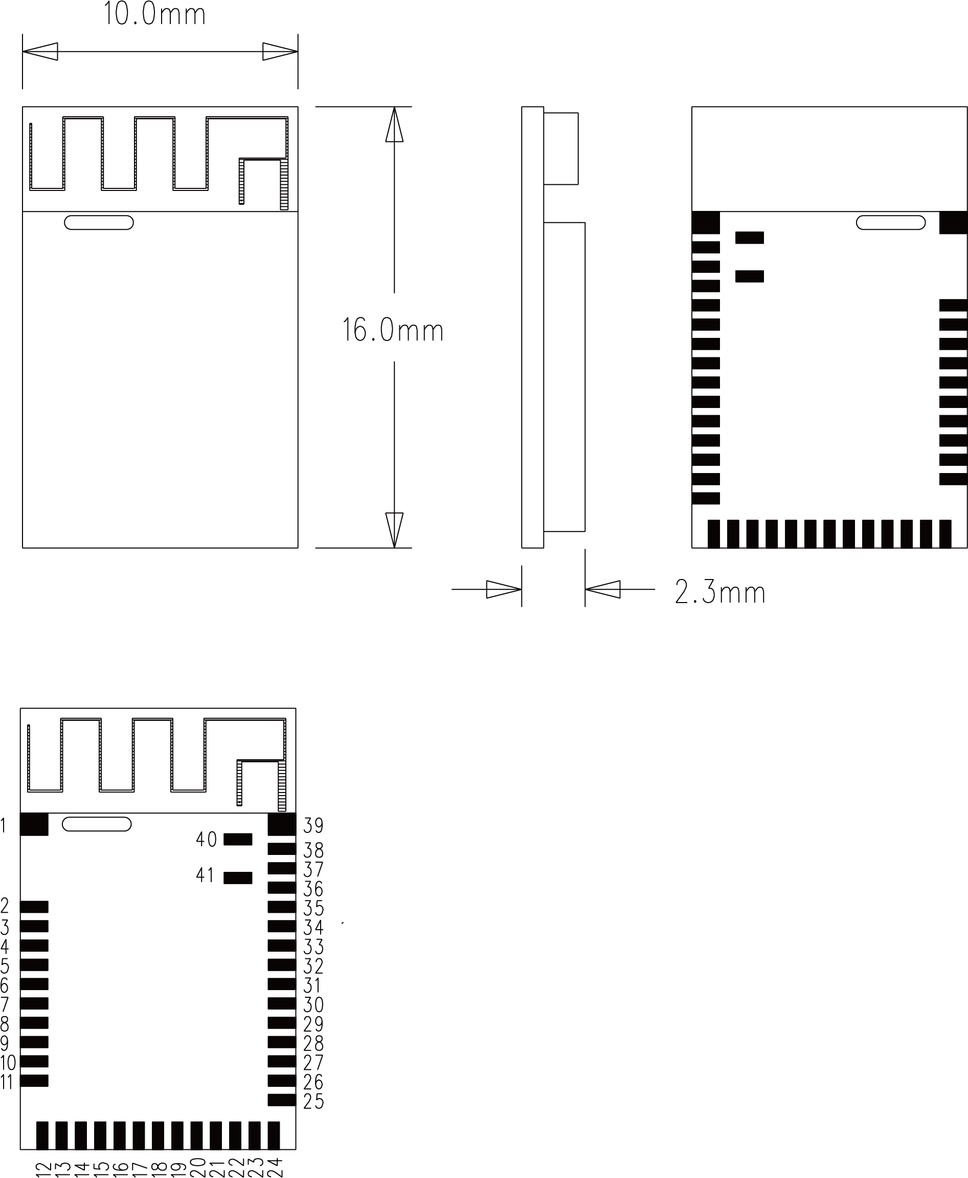
2.2. Recommended Layout of Solder Pad
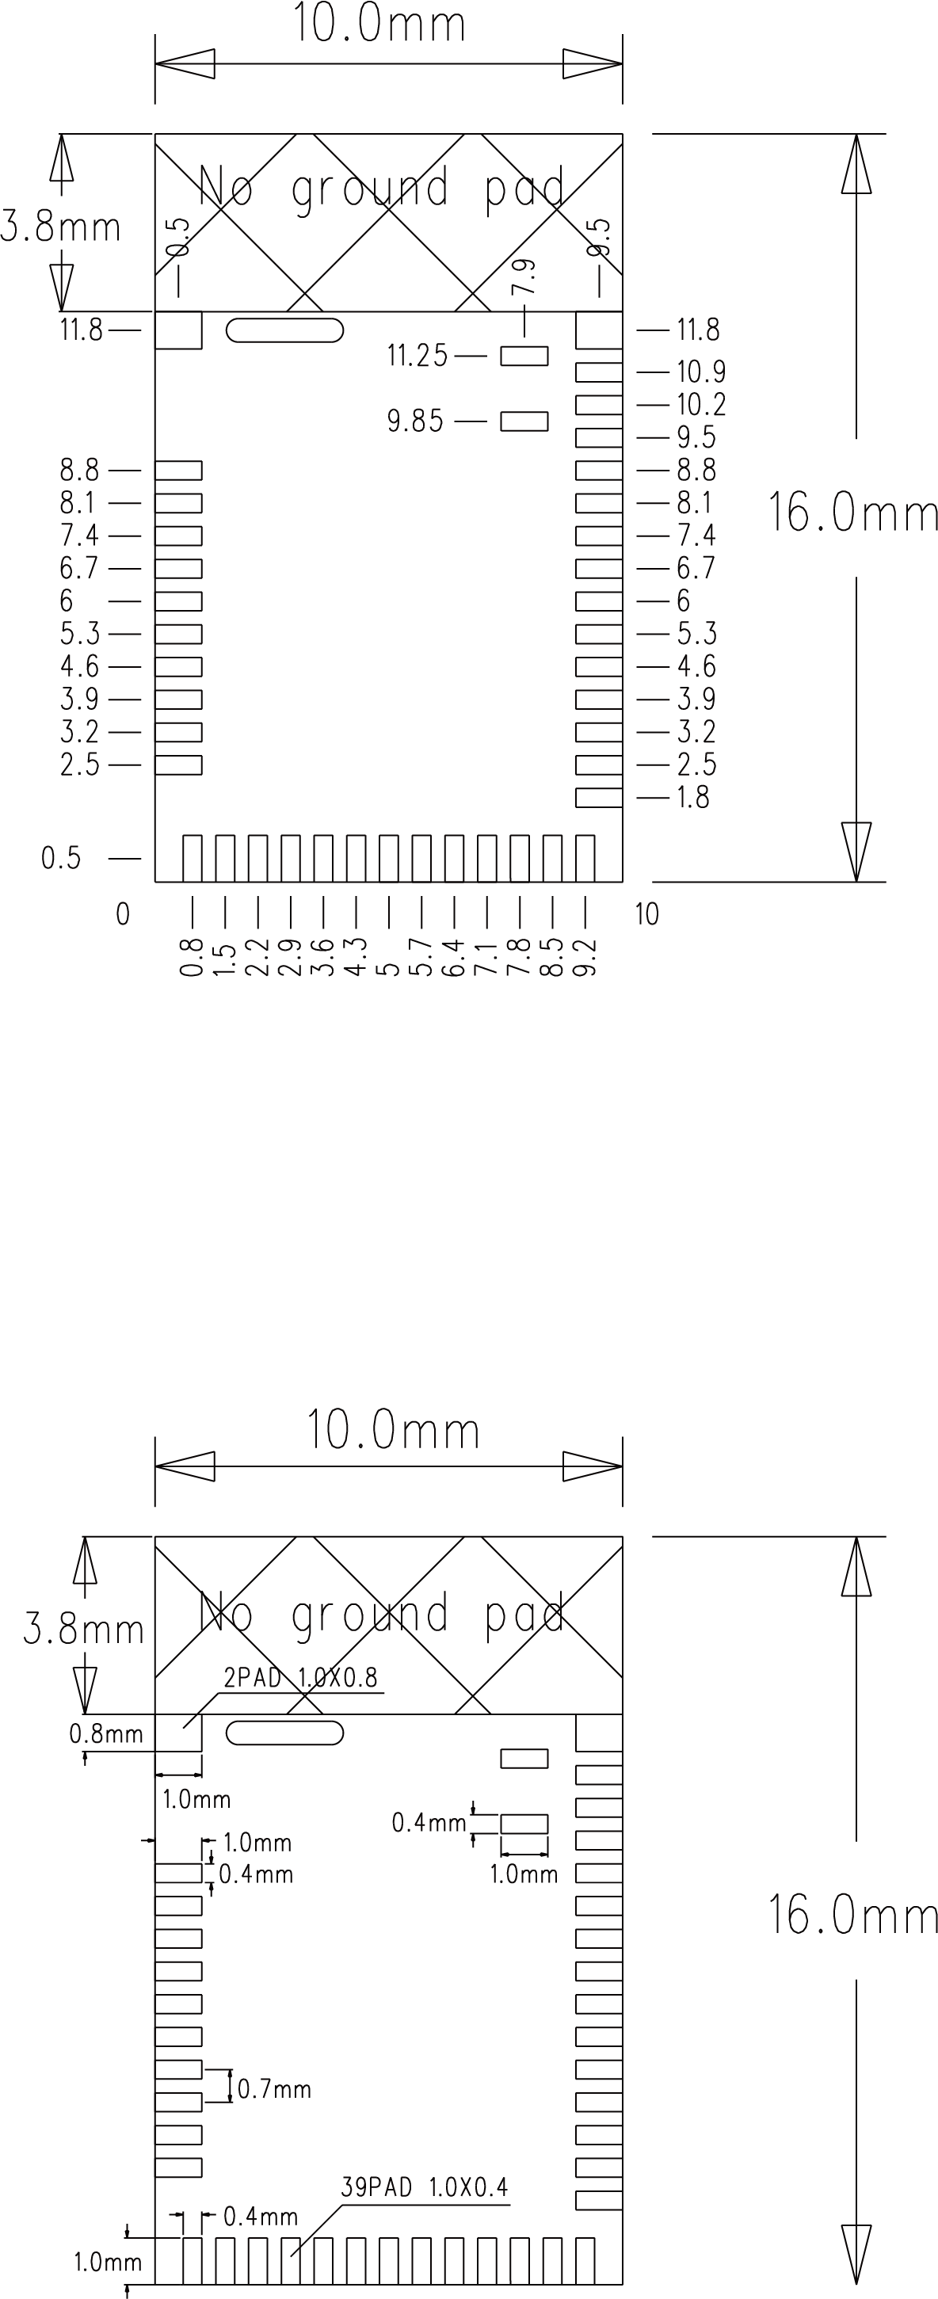

2.3. RF Layout Suggestion (aka Keep-Out Area)
Please follow below instruction to avoid from having Ground Pad in the area of our RF test pad. Otherwise, it may cause shortage to the module

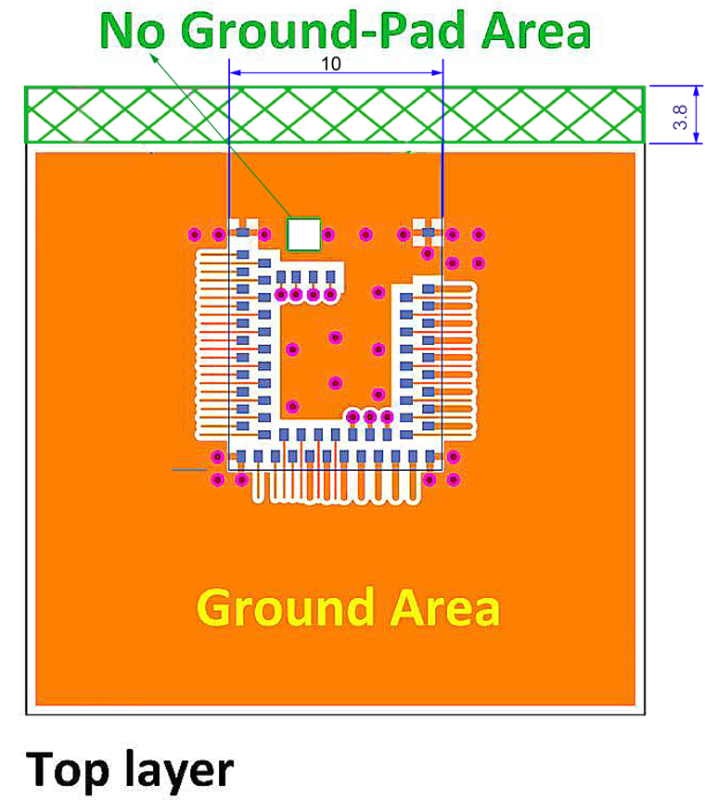

2.4. Pin Assignment
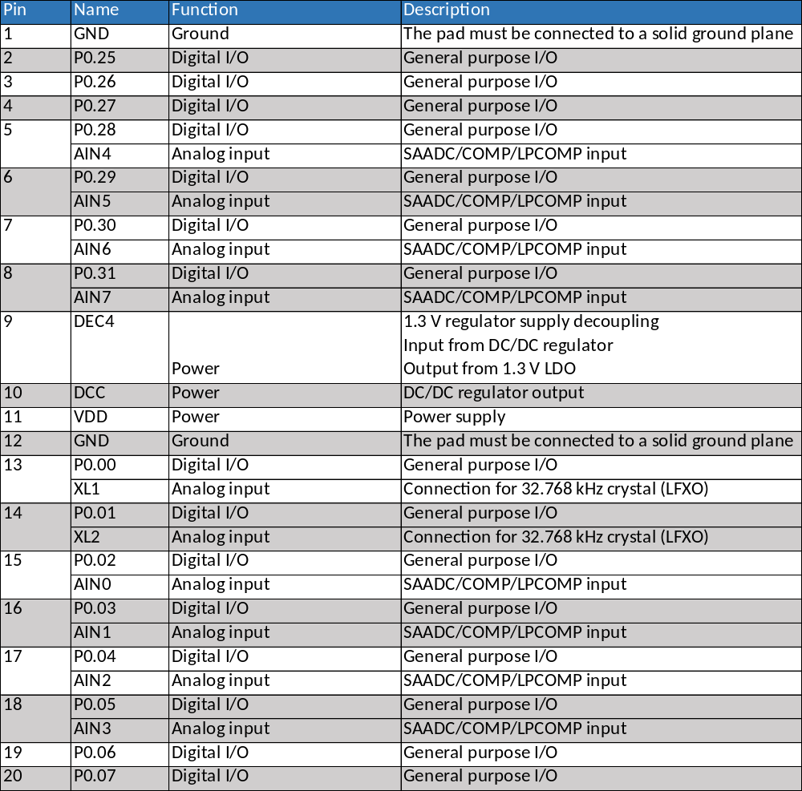
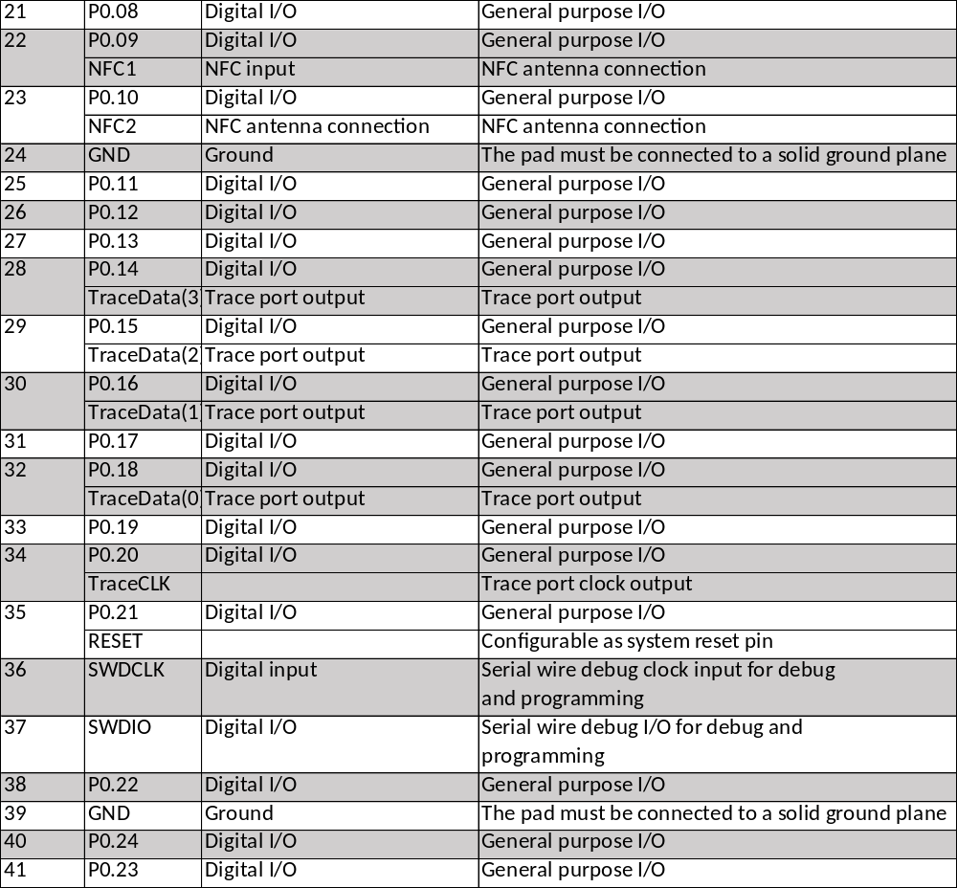

3. Main Chip Solution

RF IC | Crystal Frequency
Nordic NRF52810 | 32MHZ

32MHz crystal and RF (VDD) DC/DC inductor (Reg1) are already inside the module.

4. Shipment Packaging Information

Model | Antenna | Photo
DK9180D | PCB | 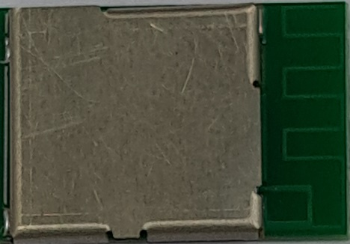
DK9182D | Chip/Ceramic | 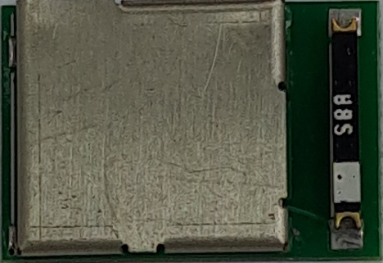

※Unit Weight of Module: 0.68g (±0.02g)
※Packaging Type: Anti-static Tape & Reel

 | Tape & Reel
MPQ  (Min. Package Qty) | 600 pcs per reel
Carton Contents  (per Carton) | 600 pcs
Carton Dimension  L*W*H cm | 37*36*6
Gross Weight | About 1.9kgs

4.1. Tape & Reel Packaging
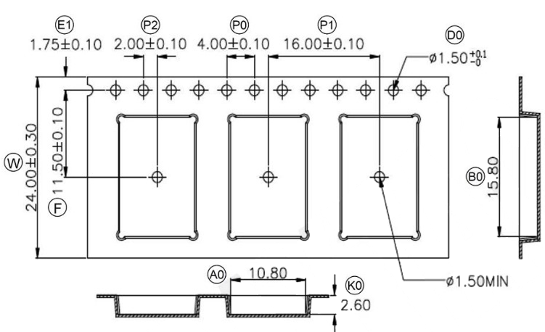

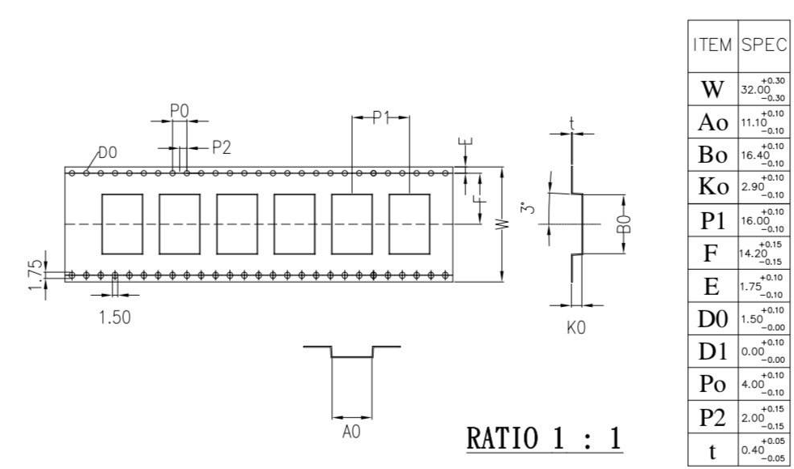

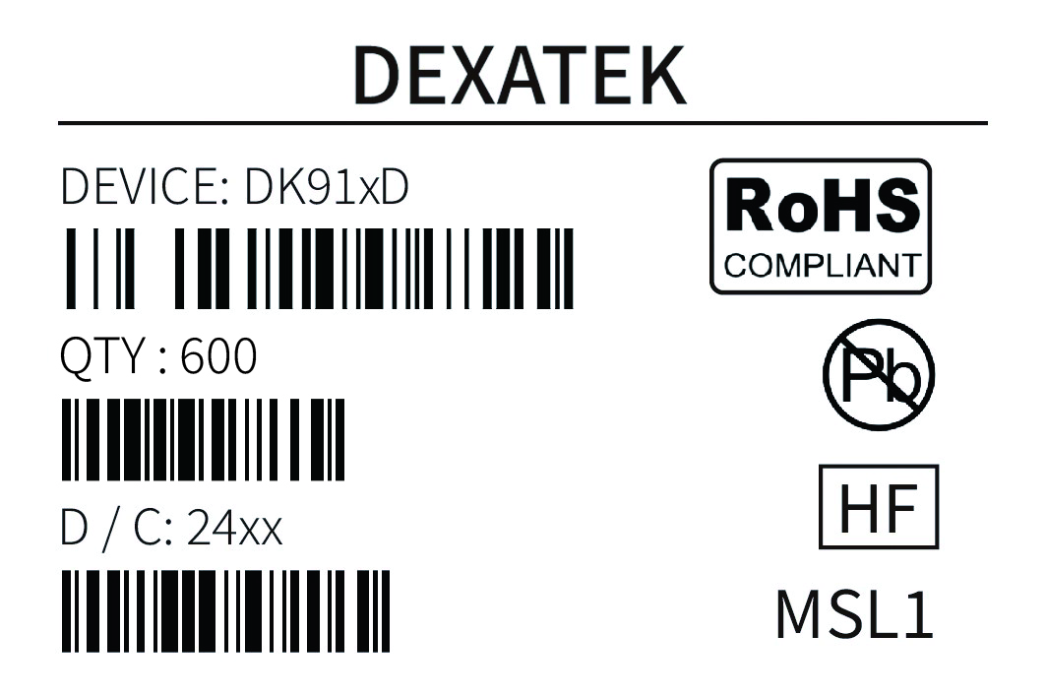

Part Number | DK91xxD
Quantity | 600 pcs
Date Code | 24xx

4.2. Marking on Metal Shield
4.2.1. Label
DK9180D
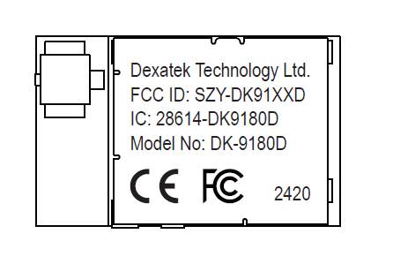
DK9182D
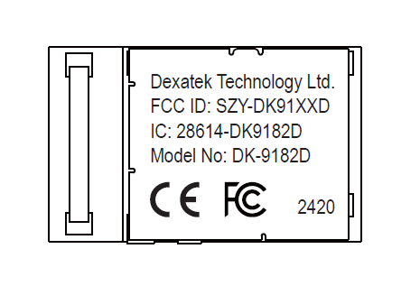
5. Specification
Any technical spec shall refer to Nordic’s official documents as final reference.

5.1. Absolute Maximum Ratings
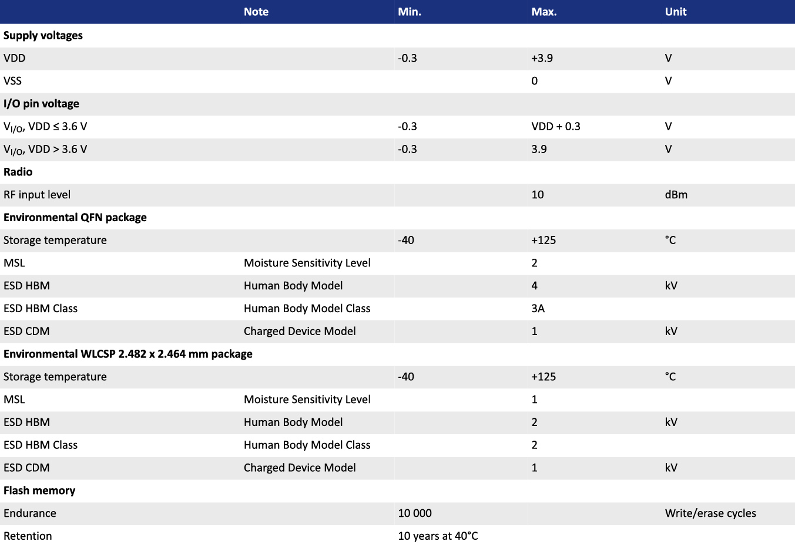

5.2. Operating Conditions
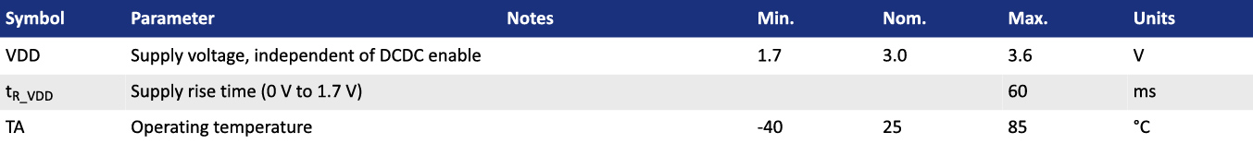

5.3. Electrical Specifications
5.3.1. General Radio Characteristics
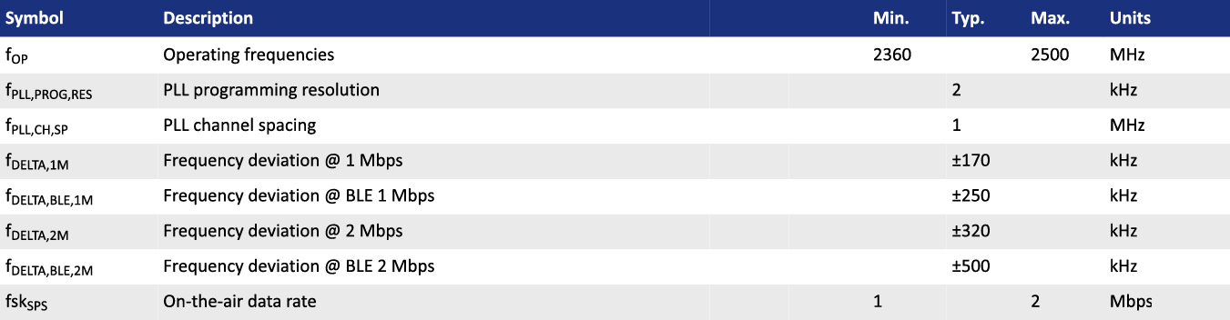

5.3.2. Radio Current Consumption (Transmitter)
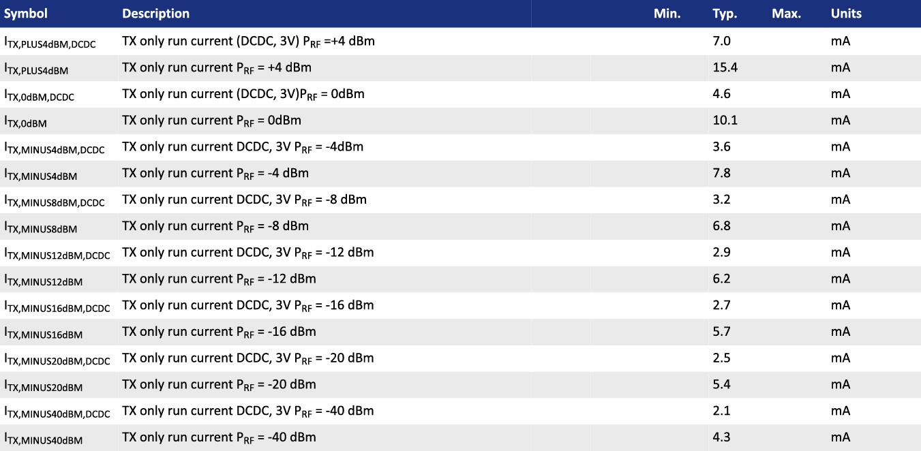

5.3.3. Radio Current Consumption (Receiver)
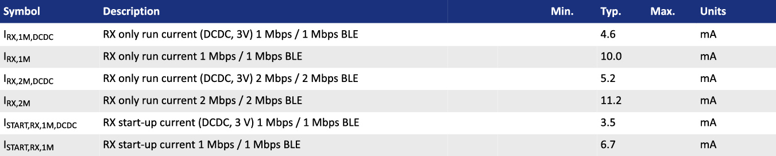

5.3.4. Transmitter Specification
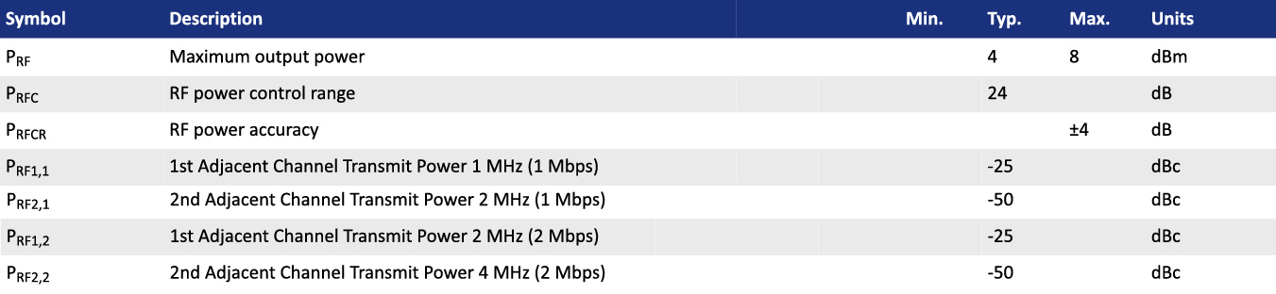

5.3.5. Receiver Operation
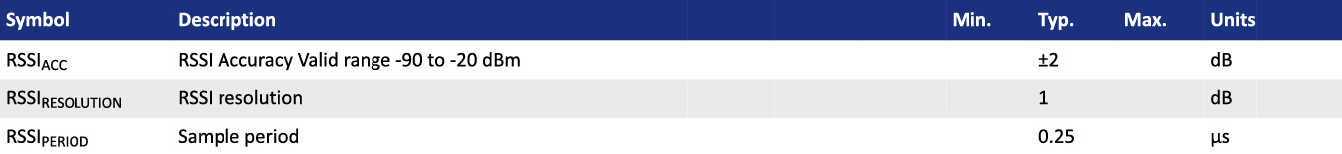

5.3.6. RX Selectivity
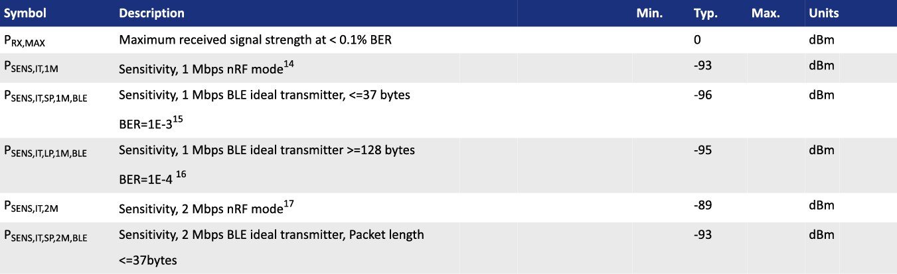
Remark: Wanted signal level at PIN= -67dBm. One interferer is used, having equal modulation as the wanted signal. The input power of the interferer where the sensitivity equals BER = 0.1% is presented.
5.3.7. RX Intermodulation
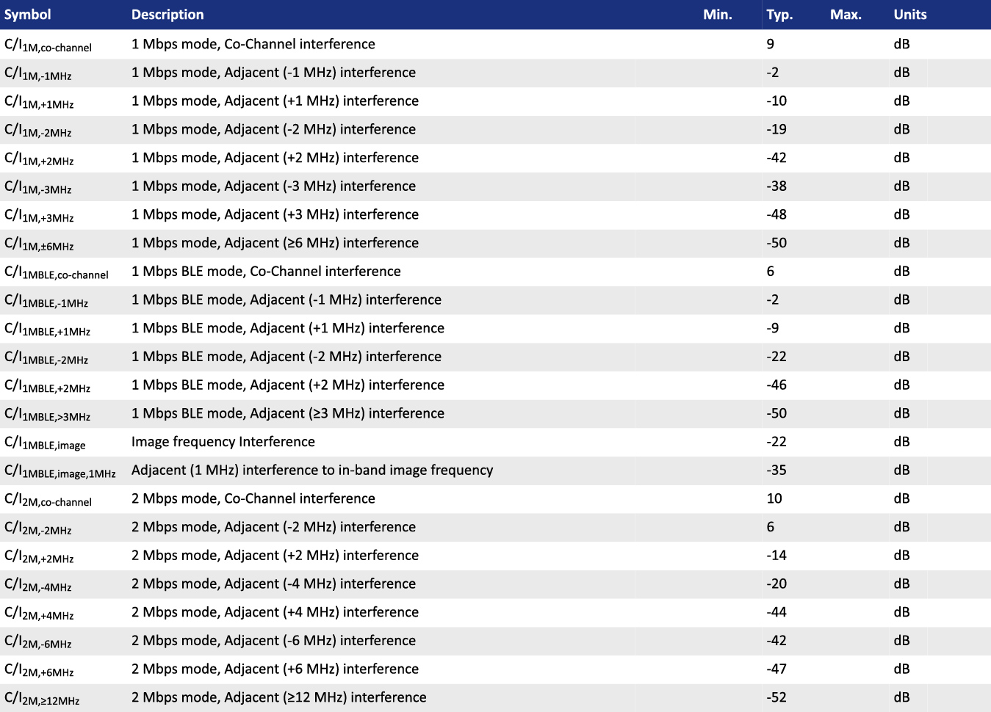
Remark: Wanted signal level at PIN= -64dBm. Two interferers with equal input power are used. The interferer closest in frequency is not modulated, the other

interferer is modulated equal with the qanted signal. The input power of the interferers where the sensitivity equals BER= 0.1% is presented.
5.3.8. Radio Timing Parameters
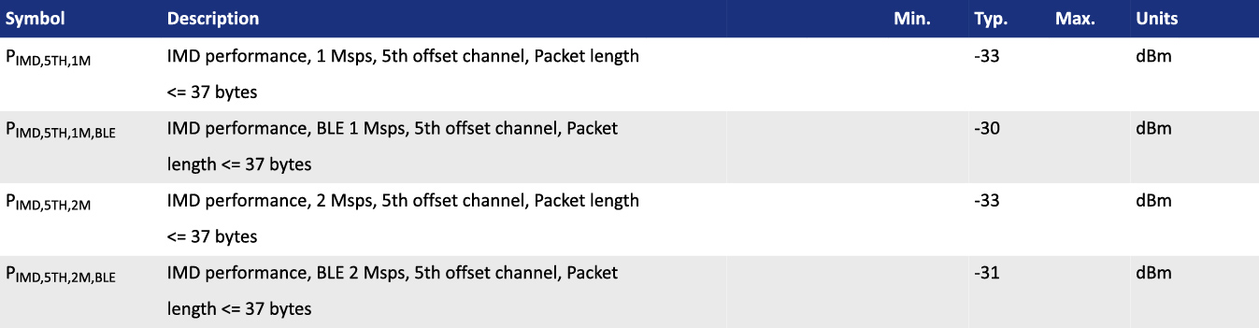

5.3.9. RSSI Specifications
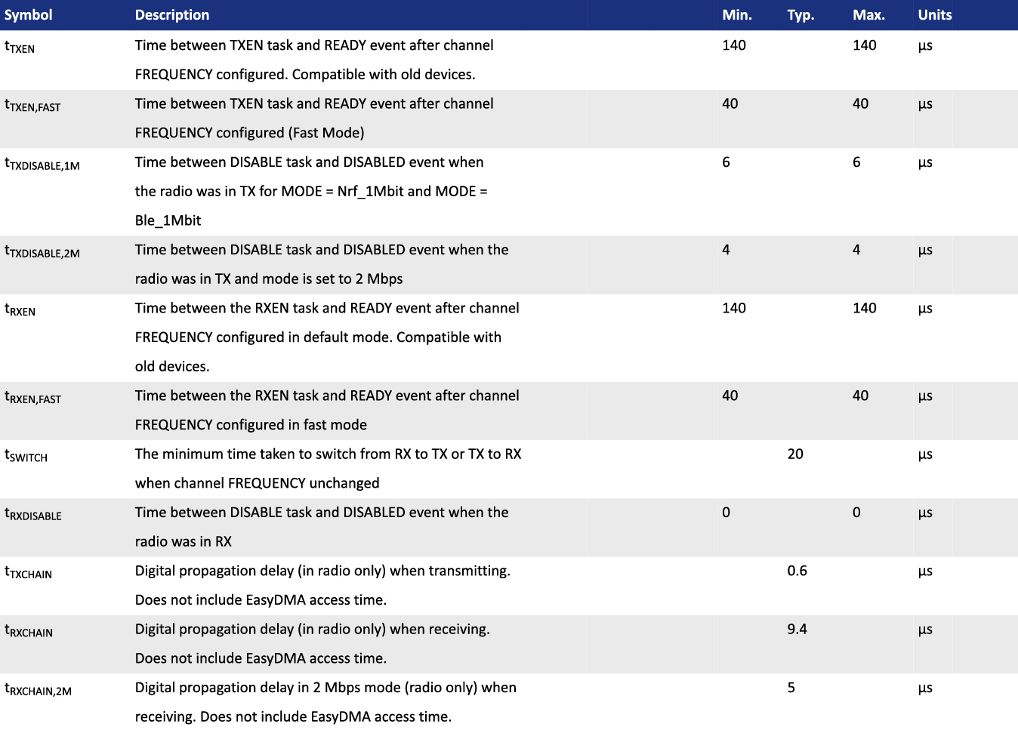

5.3.10. CPU
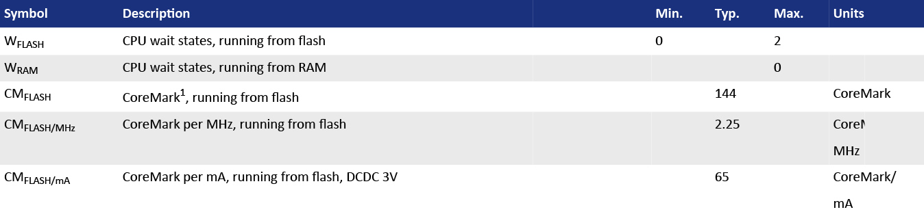

5.3.11. Power Management
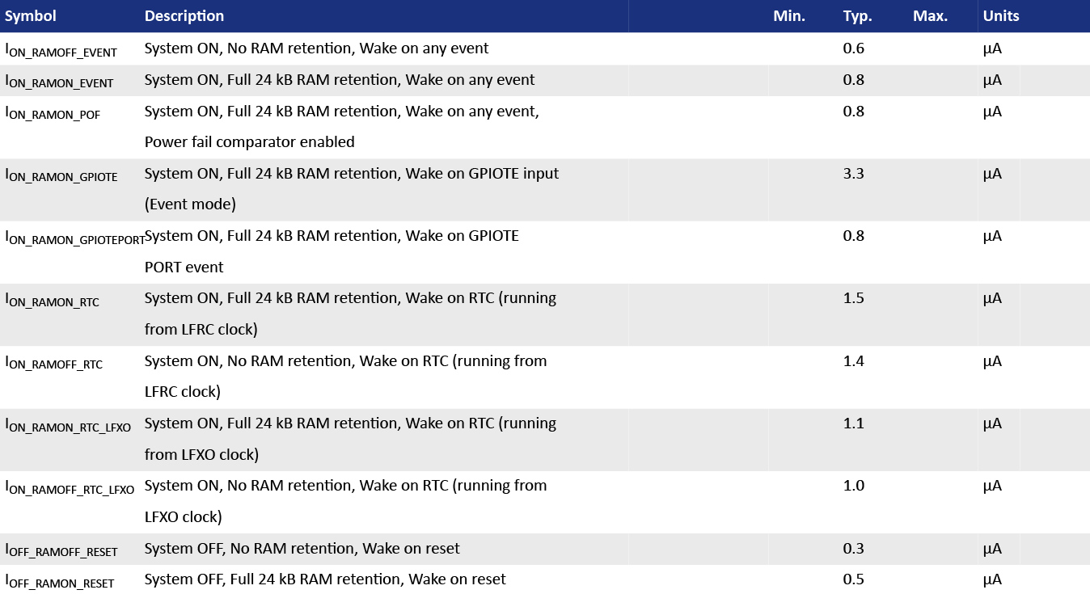

6. Block Diagram
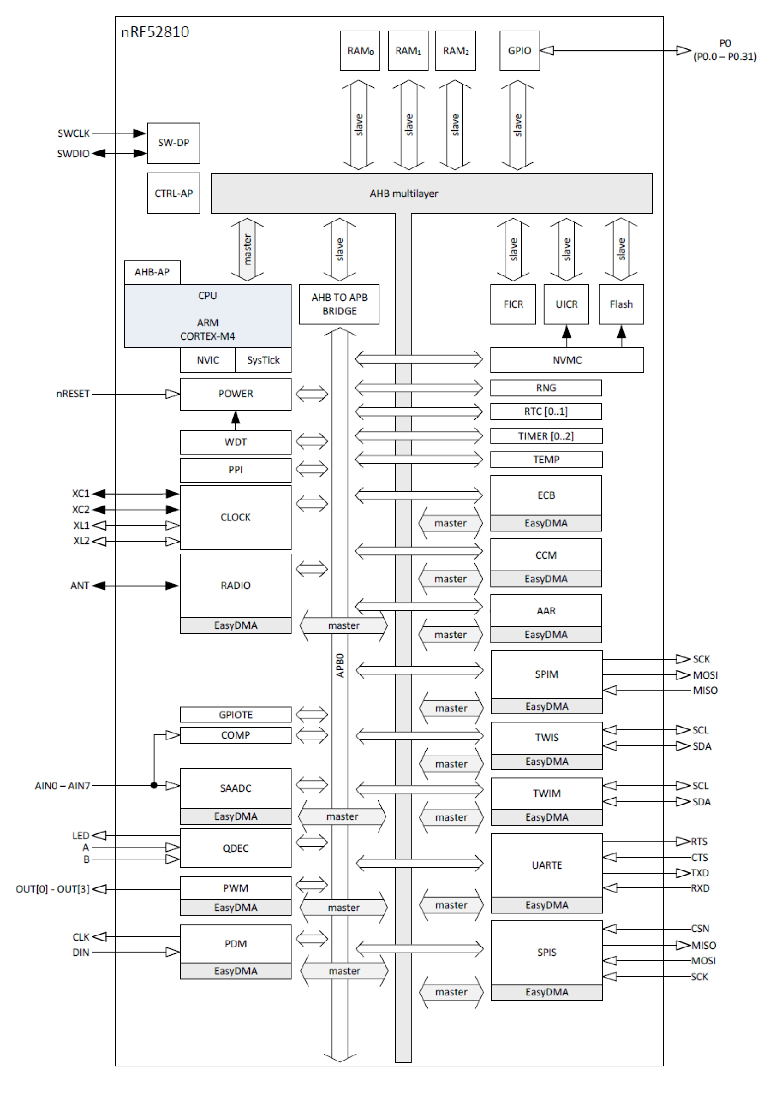

7. Antenna
Below chart shows a few options of external antenna which has been tested and approved to use with DK9180D & DK9182D

DK9180D
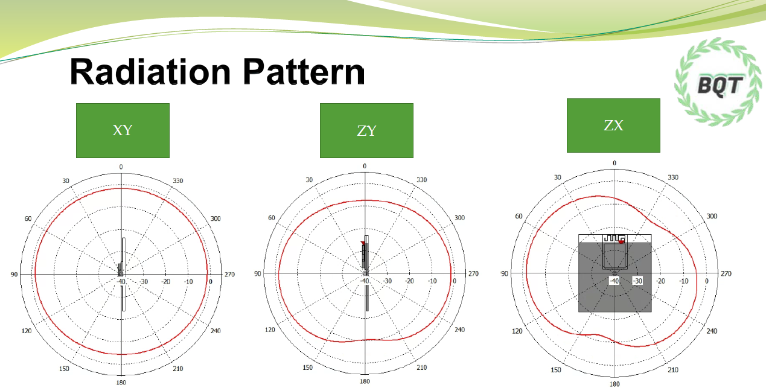
DK9182D
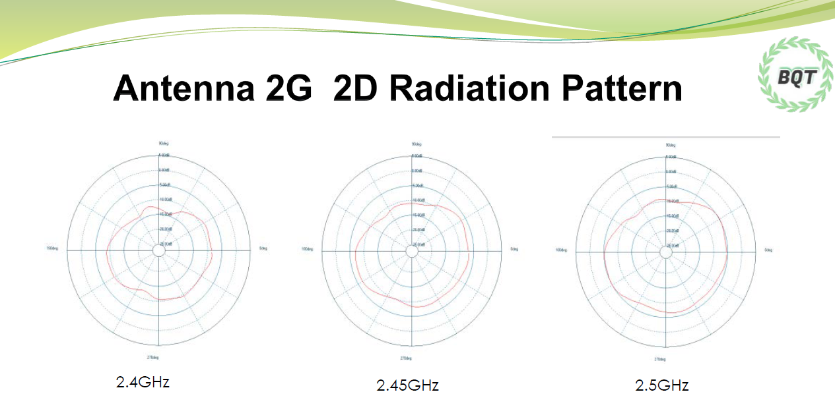

8. Reference Circuit
This is a notification for circuit combinations and please refer below caution for specification, and carefully in detail description as applies to adapt on peripherals circuits.

The module default is define on “LDO mode” and must add external 32.768 kHz crystal for MCU boot up.

Pin DEC4 had built in 1𝛍𝐅 decoupling capacitor in module.
Please remove Y1/C7/C9 when using the internal 32MHz RC oscillator.
Please add L1/L2/C2 in circuit if power setup “DC-DC” mode.

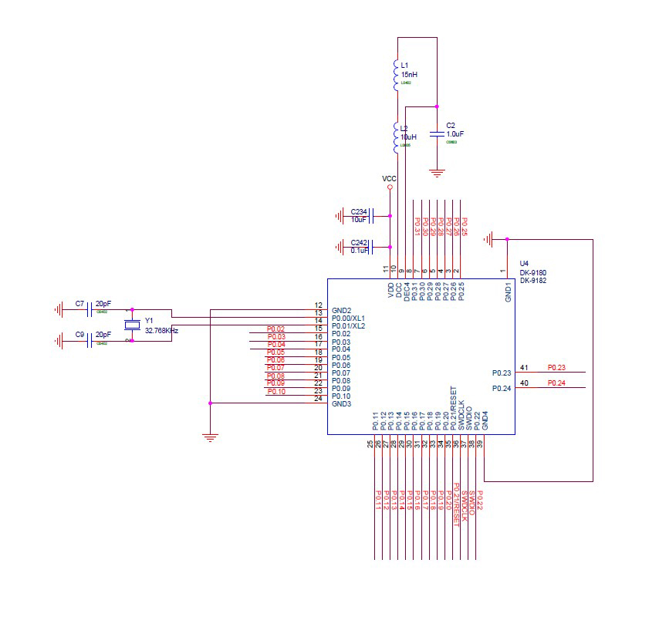

9. Notes and Cautions
1. Follow the conditions written in this specification, especially the control signals of this module.
2. The supply voltage should abide by the maximum ratings and must to supply within range of specification.
4. This module should not be mechanically stressed when installed.
5. Keep this module away from heat. Heat is the major cause of decreasing the life time of these modules.
6. Avoid assembly and use of the target equipment in conditions where the module temperature may exceed the maximum tolerance.
7. Keep this module away from other high frequency circuits.
8. Refer to the recommended pattern when designing a board.
9. Do not expose modules under direct sunlight for long duration. Modules should be kept away from humid and salty air conditions, and any corrosive gasses or substances. Store it within -40℃ to +125℃ before and after installation.

10. Basic Facts for nRF52 Family

Below chart shows basic spec for Nordic nRF52 family, which is helpful to understand the differences between each SoC. Any discrepancy shall referto Nordic’s technical document as final reference.

Solution | Nordic  52840 | Nordic  52833 | Nordic  52832 | Nordic  52810
Antenna | Ipex |  | Ipex
Antenna Vendor | Χ |  | Χ
RAM (KB) | 256KB | 128KB | 64KB | 24KB
Internal Flash | 1MB | 512KB | 512KB | 192KB
External flash | Χ | Χ | Χ | Χ
PIN OUT | 48 | 42 | 32 | 32
Shielding Case | O | O | O | O
Package | 6x6mm QFN48 | 7x7mm aQFN™73 | 6x6mm QFN48 | 6x6mm QFN48
RF | BT5.3 | BT5.3 | BT5.3 | BT5.3
PA | Χ | Χ | Χ | Χ
Operating Temp | -40~85C | -40~105C | -40~85C | -40~85C
Tx Power(MAX) | 8dBm | 8dBm | 4dBm | 4dBm
Supply Voltage | 1.7V~5.5V | 1.7V~5.5V | 1.7V~3.6V | 1.7V~3.6V

11. Useful Links
- Nordic Infocenter: Nordic Semiconductor Infocenter
- Nordic DevZone: Nordic Devzone Q&A
- Nordic Document: Nordic Techdoc
- Nordic Academy : Nordic DevAcademy
- nRF52810 Product Specification: nRF52810 - Bluetooth 5.2 SoC - nordicsemi.com

Full List of DEXATEK’s BLE Modules
Nordic Solution | DEXATEK NO. | Antenna | RAM | Flash Memory
nRF52840 | DK9177A | IPEX | 256 kB | 1 MB
nRF52832 | DK9178C | IPEX | 64 kB | 512 kB
nRF52832 | DK9180C | PCB | 64 kB | 512 kB
nRF52840 | DK9181A | PCB | 256 kB | 1 MB
nRF52832 | DK9182C | CHIP | 64 kB | 512 kB
nRF52840 | DK9183A | CHIP | 256 kB | 1 MB
nRF52833 | DK9177B | IPEX | 128 kB | 512 kB
nRF52810 | DK9178D | IPEX | 24 kB | 192 kB
nRF52810 | DK9180D | PCB | 24 kB | 192 kB
nRF52833 | DK9181B | PCB | 128 kB | 512 kB
nRF52810 | DK9182D | CHIP | 24 kB | 192 kB
nRF52833 | DK9183B | CHIP | 128 kB | 512 kB

